**PRACTICAL -1**

**Aim : Introduction Virtualization Environment configuration and Cyber Lab setup (Kali, VM ware and Oracle Virtual Box).**

**Virtualization**

* Virtualization is technology that allows you to create multiple simulated environments or dedicated resources from a single, physical hardware system.
* Software called a hypervisor connects directly to that hardware and allows you to split one system into separate, distinct, and secure environments known as virtual machines (VMs).
* These VMs rely on the hypervisor’s ability to separate the machine’s resources from the hardware and distribute them appropriately.
* Virtualization helps you get the most value from previous investments.
* The physical hardware, equipped with a hypervisor, is called the host, while the many VMs that use its resources are guests.
* These guests treat computing resources—like CPU, memory, and storage—as a pool of resources that can easily be relocated.
* Operators can control virtual instances of CPU, memory, storage, and other resources, so guests receive the resources they need when they need them.

**Types of Virtualizations**

There are six areas of IT where virtualization is making headway:

1. **Network virtualization** is a method of combining the available resources in a network by splitting up the available bandwidth into channels, each of which is independent from the others and can be assigned -- or reassigned -- to a particular server or device in real time.

**-**The idea is that virtualization disguises the true complexity of the network by separating it into manageable parts, much like your partitioned hard drive makes it easier to manage your files.

1. **Storage virtualization** is the pooling of physical storage from multiple network storage devices into what appears to be a single storage device that is managed from a central console. Storage virtualization is commonly used in storage area networks.
2. **Server virtualization** is the masking of server resources -- including the number and identity of individual physical servers, processors and operating systems -- from server users. The intention is to spare the user from having to understand and manage complicated details of server resources while increasing resource sharing and utilization and maintaining the capacity to expand later.

* The layer of software that enables this abstraction is often referred to as the hypervisor.
* The most common hypervisor -- Type 1 -- is designed to sit directly on bare metal and provide the ability to virtualize the hardware platform for use by the virtual machines. KVM virtualization is a Linux kernel-based virtualization hypervisor that provides Type 1 virtualization benefits like other hypervisors. KVM is licensed under open source.
* A Type 2 hypervisor requires a host operating system and is more often used for testing and labs.

1. **Data virtualization** is abstracting the traditional technical details of data and data management, such as location, performance, or format, in favor of broader access and more resiliency tied to business needs.
2. **Desktop virtualization** is virtualizing a workstation load rather than a server. This allows the user to access the desktop remotely, typically using a thin client at the desk.

* Since the workstation is essentially running in a data center server, access to it can be both more secure and portable. The operating system license does still need to be accounted for as well as the infrastructure.

1. **Application virtualization** is abstracting the application layer away from the operating system. This way, the application can run in an encapsulated form without being depended upon on by the operating system underneath. This can allow a Windows application to run on Linux and vice versa, in addition to adding a level of isolation.

**Virtualization Environment**

- A virtualization environment allows the creation of isolated and independent virtual machines (VMs) that run multiple operating systems (OS) or applications.

* In a virtualization environment, a hypervisor is installed on the host machine, which creates multiple virtual machines with their own resources, such as CPU, memory, storage, and network interfaces.
* Each virtual machine can run its own operating system and applications, and is isolated from other virtual machines on the same host machine.

Virtualization environments can be used in cybersecurity for various purposes, including:

1. Testing and development: Cybersecurity professionals can use virtualization environments to test and develop new security technologies and configurations without risking damage to the production environment.
2. Malware analysis: Virtualization environments can be used to analyze and study malware in a controlled environment. Malware can be executed in a virtual machine without affecting the host machine or other virtual machines.
3. Forensics: Virtualization environments can be used to conduct forensic investigations on compromised systems. Investigators can create a copy of the compromised system in a virtual machine and analyze it without affecting the original system.
4. Sandboxing: Virtualization environments can be used to isolate potentially dangerous applications and websites in a sandboxed environment. If an application or website is found to be malicious, it can be terminated without affecting the host machine or other virtual machines.

**Kali Linux**

* Kali Linux is a Debian-based Linux distribution that is designed for digital forensics and penetration testing.
* It is funded and maintained by Offensive Security, an information training company. Kali Linux was developed through the rewrite of BackTrack by Mati Aharoni and Devon Kearns of Offensive Security.
* Kali Linux comes with a large number of tools that are well suited to a variety of information security tasks, including penetration testing, computer forensics, security research, and reverse engineering.
* Kali Linux is a one-of-a-kind operating system since it is one of the few platforms that are freely utilized by both good and bad guys.
* This operating system is widely used by both Security Administrators and Black Hat Hackers.
* One is responsible for detecting and preventing security breaches, while the other is responsible for identifying and perhaps exploiting security breaches.
* The number of tools configured and preinstalled on the operating system makes Kali Linux a Swiss Army Knife in any security professional's toolbox.

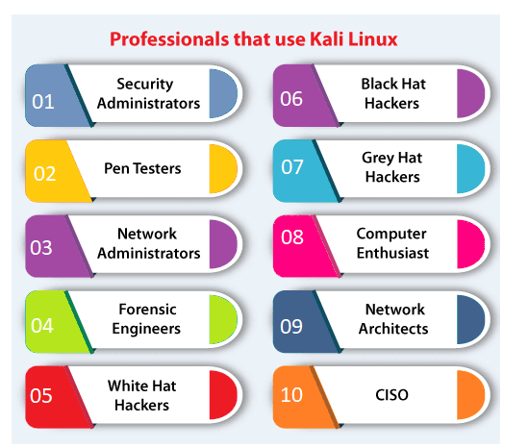

**VM ware**

- VMware is a company that provides virtualization software that enables users to create and manage virtual machines. VMware's virtualization software allows multiple operating systems and applications to run on a single physical server, which can help businesses save on hardware costs and improve efficiency.



VMware's virtualization products include:

1. VMware Workstation: This is a desktop virtualization product that allows users to create and run multiple virtual machines on a single physical computer.
2. VMware Fusion: This is a desktop virtualization product for Mac computers that allows users to run Windows, Linux, and other operating systems on a Mac without having to reboot.
3. VMware vSphere: This is a server virtualization product that allows users to create and manage virtual machines on a large scale.
4. VMware ESXi: This is a hypervisor that allows users to create and run multiple virtual machines on a single physical server.

- VMware's virtualization software is widely used in enterprise computing environments, where it can help businesses reduce hardware costs, increase efficiency, and improve flexibility. Virtualization technology has also become increasingly popular in cloud computing environments, where it enables cloud service providers to create and manage virtual machines on a large scale.

**Oracle Virtual Box**

* Oracle VM VirtualBox is cross-platform virtualization software.
* It allows users to extend their existing computer to run multiple operating systems including Microsoft Windows, Mac OS X, Linux, and Oracle Solaris, at the same time.
* Designed for IT professionals and developers, Oracle VM VirtualBox is ideal for testing, developing, demonstrating, and deploying solutions across multiple platforms from one machine.
* Oracle VM VirtualBox can display virtual machines remotely, meaning that a virtual machine can execute on one computer even though the virtual machine will be displayed on a second computer.
* The virtual machine can be controlled from the second computer, as if the virtual machine was running on that computer.



* Oracle VirtualBox is a type-2 hypervisor that allows users to create and run virtual machines on a host operating system. From a cybersecurity perspective, VirtualBox can be a valuable tool for testing and developing software, as well as for isolating potentially risky applications or operating systems from the host environment.

Here are some key points to consider when assessing VirtualBox from a cybersecurity perspective:

1. Virtualization can increase security: Virtual machines can be isolated from the host operating system, providing an additional layer of security. Virtual machines can also be easily backed up and restored, which can be useful in the event of a security breach.
2. Proper configuration is key: As with any software, VirtualBox should be properly configured to ensure maximum security. This includes setting strong passwords, enabling encryption, and configuring firewalls.
3. VirtualBox vulnerabilities: As with any software, VirtualBox is not immune to vulnerabilities. Users should stay up-to-date with security patches and updates, and regularly review security advisories and bulletins.
4. Shared folders and networking: VirtualBox allows for shared folders and networking between the host and guest operating systems. While this can be convenient, it also introduces potential security risks. Users should carefully configure shared folders and networking to minimize these risks.

**Configuration/Installation of Virtual Environment in Oracle Virtual Box .**

1. Download and Install VirtualBox

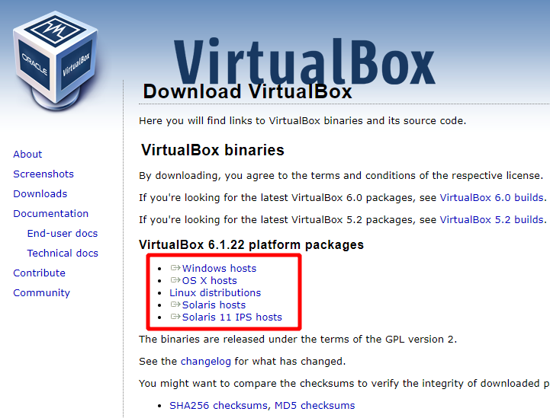

Once the download is completed, double-click on the installation file to launch the VirtualBox installer.

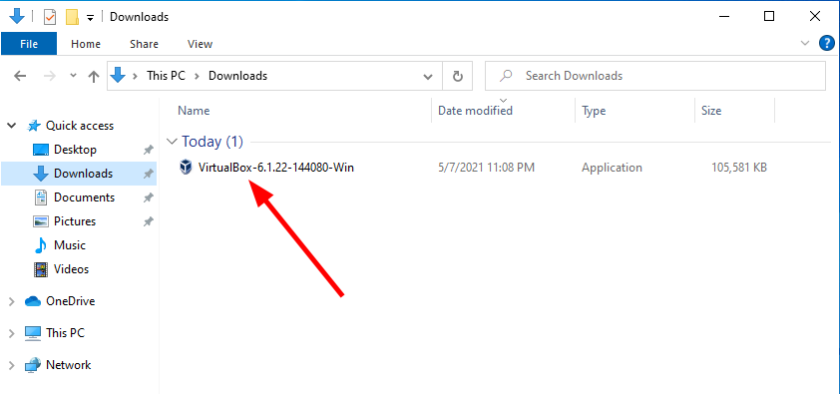

On the VirtualBox Welcome window, click the Next button

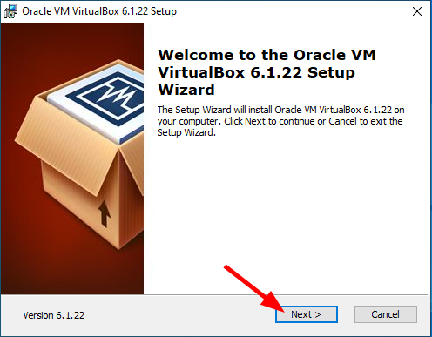

On the VirtualBox Customer Setup window, click the Next button

Alternatively, you can browse for a new location on your machine to install the VirtualBox or customize your installation further

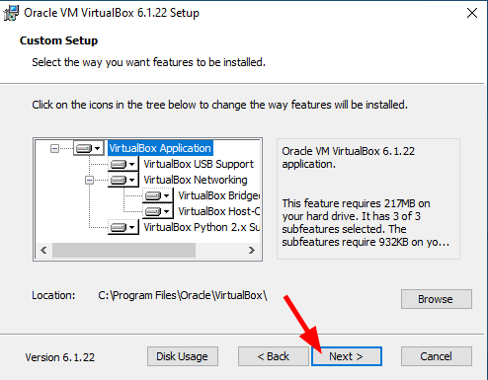

Check/uncheck the shortcut options or leave the default selection then click the Next button

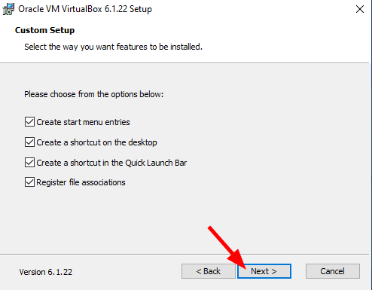

The VirtualBox installer will proceed to configure the virtual network interface on your VM therefore the network connection will reset shortly. Click Yes to continue the installation.

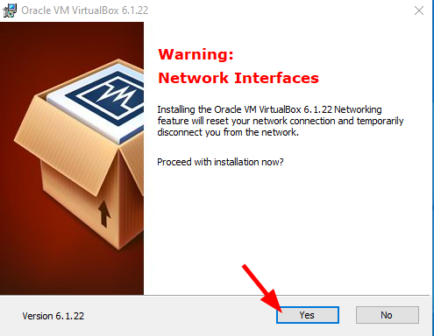

On the Ready to Install window click Install to start the VirtualBox installation.

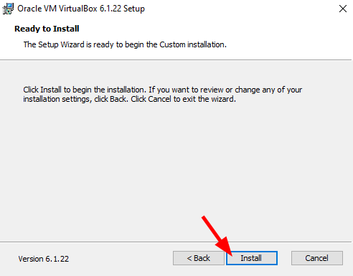

On the User Account Control window, click Yes [Figure 1.8].

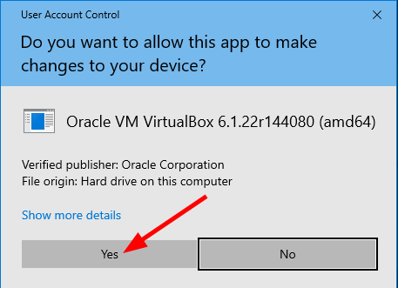

VirtualBox installation – User Account Control.

When prompted to allow the Oracle Corporation Universal Serial Bus controller, click the Install button

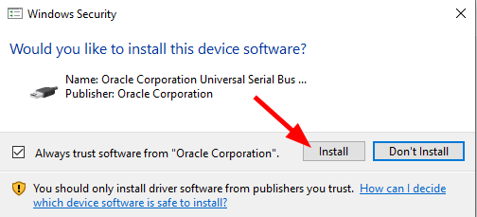

VirtualBox installation – Oracle virtual USB controller.

The VirtualBox installation is now completed. Click the Finish button to exit the installer

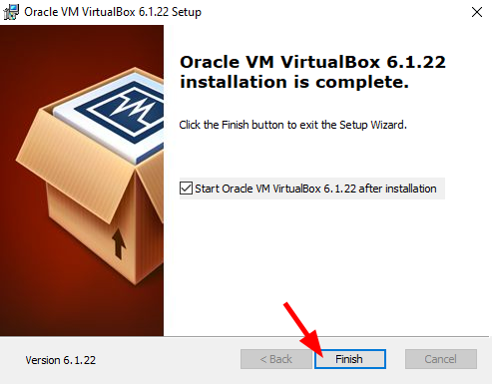

VirtualBox installation – Finish.

VirtualBox is now installed on your computer. You should see a window similar to the one in below.

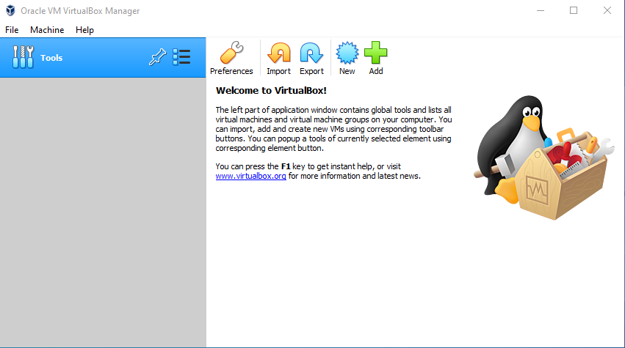

2. Install Kali Linux in VirtualBox

Step 1: Download And Import Kali Linux VM In VirtualBox.

Step 2: Network Isolate Kali Linux VM

3. Install Windows 10 on VirtualBox

Step 1: Download Windows 10 VirtualBox VM

Step 2: Import Windows 10 VM in VirtualBox

Step 3: Boot into Windows 10 VM

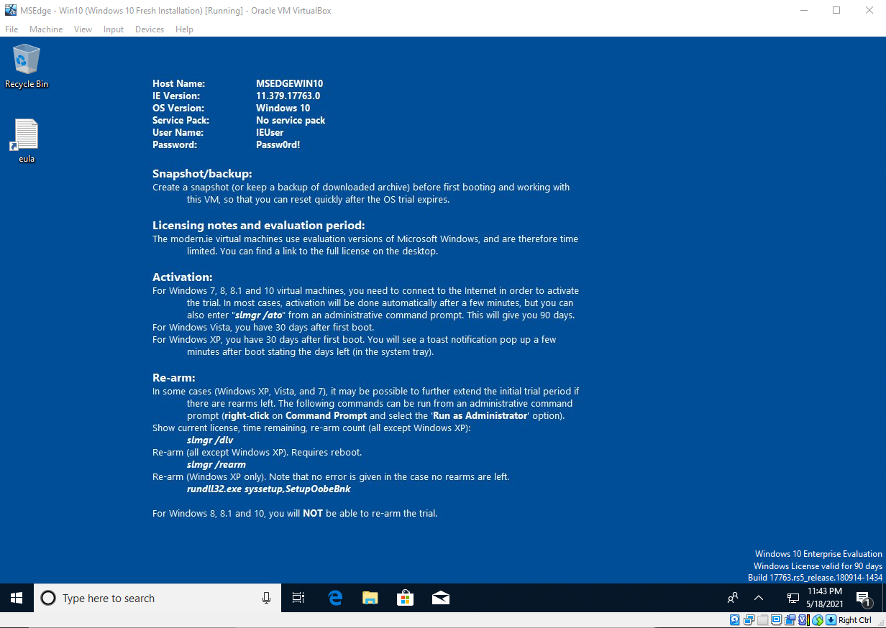

**Steps to install Kali Linux**

Step 1: Visit the Kali Linux official website and install kali linux OVA file.

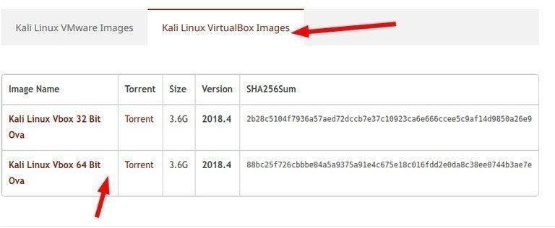

Step 2: Open VirtualBox and click on import or File>Import Appliance.

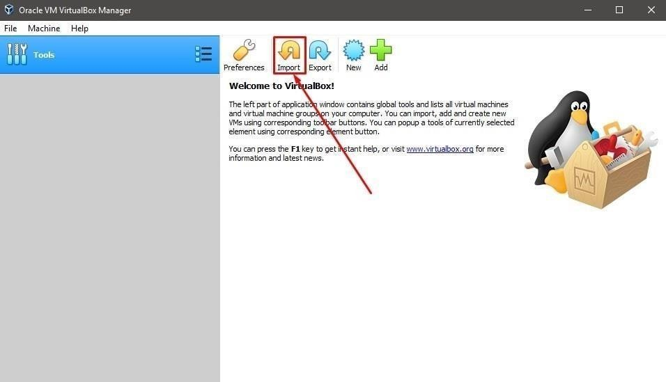

Step 3: Import the OVA file of kali Linux from disk file in the desired path.

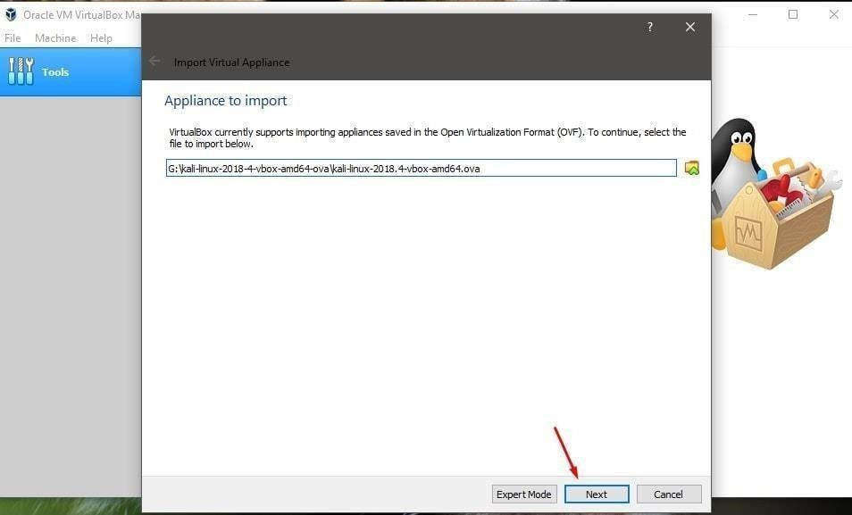

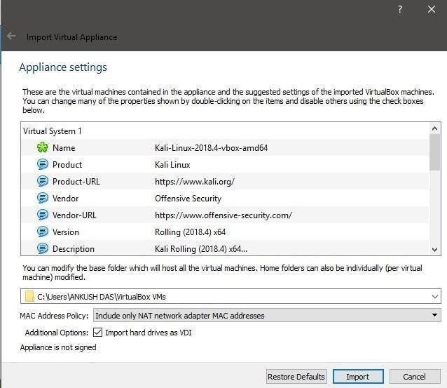

Step 4: After getting install click on start button to get start with kali. The default username in Kali Linux used to be root and the default password was root. But since

January 2020, Kali Linux is not using the root account. Now, the default account and password both are kali.

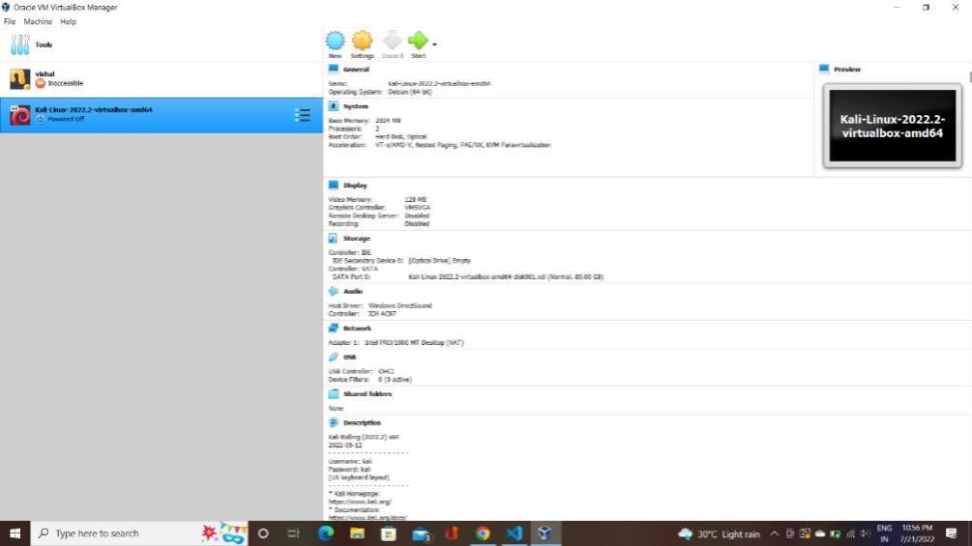

**PRACTICAL -2**

**Aim : Information Gathering using NMAP framework and study about port scanning.**

**Information Gathering**

An information-gathering process is the act of gathering information on a possible target. This might be done as part of penetration testing, network security monitoring, or other cybersecurity chores.

It is the first phase of ethical hacking that is to gather all the possible information about the target to find the weaknesses or vulnerabilities.

**Nmap**

* Nmap is an open-source utility for network discovery.
* Network Mapper is a security auditing and network scanning independent tool developed by Gordon Lyon.
* It is used by network administrators to detect the devices currently running on the system and the port number by which the devices are connected.
* Many systems and network administrators are used for managing network inventory, service upgrade schedules, monitoring hosts and service uptime.
* At the top-level, Nmap is defined as a tool that can detect or diagnose services that are running on an Internet-connected system by a network administrator in their networked system used to identify potential security flaws. It is used to automate redundant tasks, such as monitoring the service.

**Working of Nmap**

* Nmap is convenient during penetration testing of networked systems. Nmap provides the network details, and helps to determine the security flaws present in the system. Nmap is platform-independent and runs on popular operating systems such as Linux, Windows, and Mac.

Nmap is a useful tool for network scanning and auditing purposes.

1. It can search for hosts connected to the Network.
2. It can search for free ports on the target host.
3. It detects all services running on the host with the help of operating system.
4. It also detects any flaws or potential vulnerabilities in networked systems.

**Features of Nmap**

1. Host discovery: Nmap can identify live hosts on a network by sending a series of probes to different IP addresses and analyzing the responses.
2. Port scanning: Nmap can scan a range of TCP and UDP ports to identify open ports on a host, as well as the services running on those ports.
3. Operating system identification: Nmap can use various techniques to identify the operating system running on a target host, such as analyzing TCP/IP fingerprint data.
4. Service and version detection: Nmap can identify the services running on open ports, as well as the version information of those services.
5. Scriptable interaction: Nmap can be extended with custom scripts written in various languages, which can be used to automate certain tasks or customize the tool's behavior.
6. Output customization: Nmap provides various options for customizing the output of its scans, including different formats such as XML, grepable, and normal.
7. Performance tuning: Nmap provides various options for tuning the performance of its scans, such as setting the number of parallel probes and adjusting timeouts.
8. Stealth scanning: Nmap provides various options for stealth scanning, such as using decoy hosts and fragmenting packets, to avoid detection by intrusion detection systems (IDS) and firewalls.

**Commands**

##### Ping scan -

Scans the list of devices up and running on a given subnet. Here we ping scan mbit website using the follwing command:

>>nmap –sP hostname

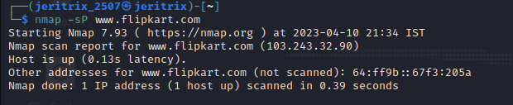

**2) Scan a single host –**

The following syntax is used to scan to scan single host or ip address we can also give the ip of the website instead of host name

Use the asterisk (*) to scan all of the subnets at once.

> nmap 192.164.1.*

>> nmap hostname(or ip-address)

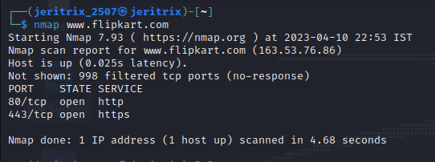

##### 3) Sealth Scan -

Stealth scanning is performed by sending an SYN packet and analyzing the response. If SYN/ACK is received, it means the port is open, and you can open a TCP connection. However, a stealth scan never completes the 3-way handshake, which makes it hard for the target to determine the scanning system(-sS, sW, sM, sA, sT). >>nmap -sS hostname

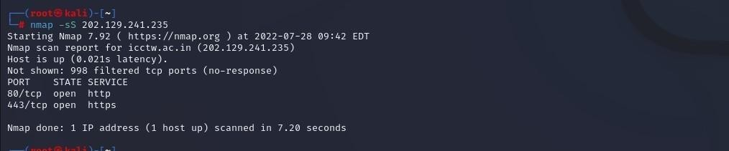

##### 4) Version Scan –

This command is use to scan the version of the service running on the port.

>>nmap –sV hostname

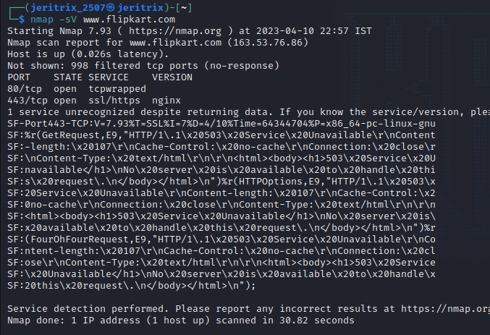

##### 5) OS detection:

It enables OS detection of website. Now we need to run the actual commands to perform OS detection using NMAP, and at first, we will get the IP address of the host system, and then will perform a scan to get all active devices on the network.

>> nmap –O sitename

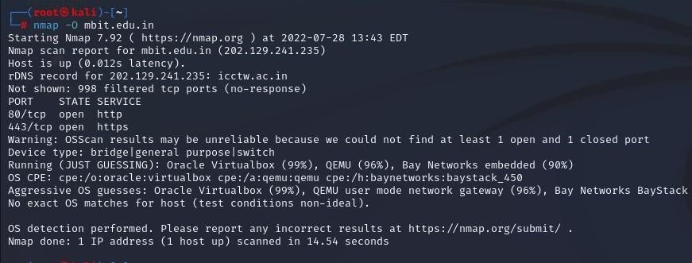

**6) Port Scan:**

We use this command to scan for the number of ports that are provided by the given site. A range of ports can be scanned by separating them with a hyphen.

> nmap -p 76–973 192.164.0.1

>>nmap –p sitename

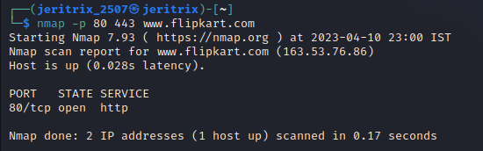

##### 7) protocol scan -

This command helps scan the protocol used for the site which is important for hacking.

>>nmap –sO sitename

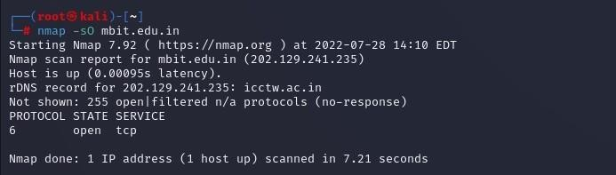

**8) ICMP Echo Request Ping (-PE) -**

A ping command sends an ICMP(Internet Control Message Protocol) echo request to the target host. The target host responds with an echo reply. The ICMP echo request ping sends an ICMP echo request to the IP address of the destination machine. In the normal type of ICMP echo request, a combination of TCP and ACK pings is sent. Using option -PE, the ICMP echo request can be specified as the nmap ping method without coupling TCP ACK ping.

>> nmap -PE www.flipkart.com

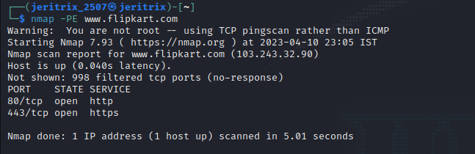

##### 9) (-Pn) No Ping -

This option skips the host discovery stage altogether. Normally, Nmap uses this stage to determine active machines for heavier scanning and to gauge the speed of the network. By default, Nmap only performs heavy probing such as port scans, version detection, or OS detection against hosts that are found to be up. Disabling host discovery with -Pn causes Nmap to attempt the requested scanning functions against *every* target IP address specified.

>>nmap –Pn www.flipkart.com

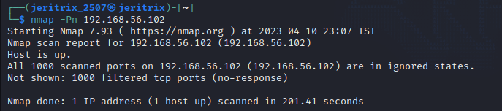

**10) (-PA) TCP ACK Ping** -

Instead of using the default option of both an ICMP echo request and a TCP ACK, the – PA option sends a TCP ACK and forgoes any ICMP echo requests. This is a good alternative when the use of ICMP is not applicable because of packet filtering or firewalls.

>>nmap –PA [www.flipkart.com](http://www.flipkart.com)

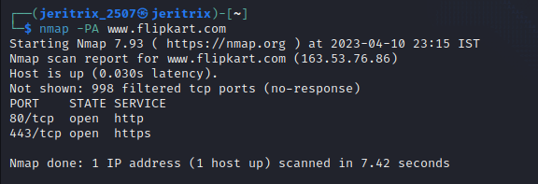

**11) UCP Scan (-sU) -**

UDP services are widely deployed. Because UDP scanning is generally slower and more difficult than TCP, some security auditors ignore these ports. UDP scan is activated with the -sU option. It can be combined with a TCP scan type such as SYN scan (-sS) to check both protocols during the same run.

>> nmap –sU [www.flipkart.com](http://www.flipkart.com)

**12) (-sA) TCP ACK scan -**

This scan is different than the others discussed so far in that it never determines open (or even open|filtered) ports. It is used to map out firewall rulesets, determining whether they are stateful or not and which ports are filtered.

>>nmap –sA google.com

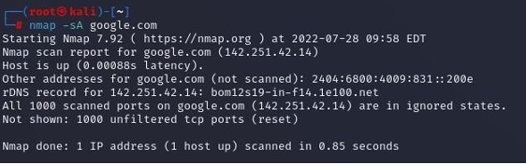

**13) (-sW) TCP Window scan -**

Window scan is exactly the same as ACK scan except that it exploits an implementation detail of certain systems to differentiate open ports from closed ones, rather than always printing unfiltered when a RST is returned.

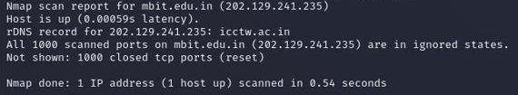

**14) (-sZ) SCTP COOKIE ECHO scan -**

SCTP COOKIE ECHO scan is a more advanced SCTP scan. It takes advantage of the fact that SCTP implementations should silently drop packets containing COOKIE ECHO chunks on open ports, but send an ABORT if the port is closed

>> nmap –sZ google.com

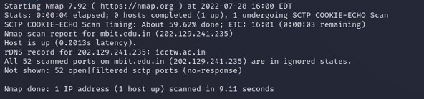

**15) Script Summary**

Gathers information from an IRC server. It uses STATS, LUSERS, and other queries to obtain this information.

>>nmap –sV –sC [www.flipkart.com](http://www.flipkart.com)

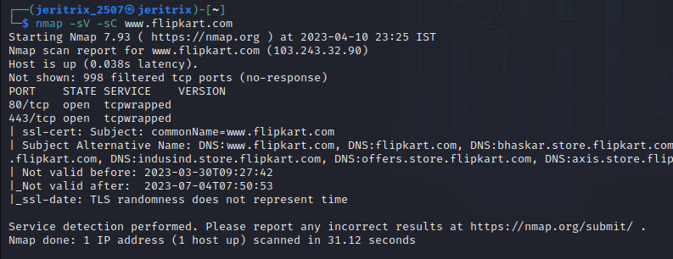

16) OS detection:

Enables OS detection and services, script scanning and tracerouting.

>>nmap –www.flipkart.com

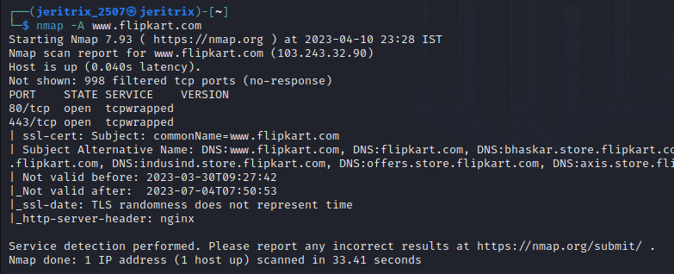

**PRACTICAL -3**

**Aim : Understand packet capturing tool Wireshark or Ethercap and analysis of those packets.**

**Packet Capturing**

* Packet capture is a vital tool used to keep networks operating safely and efficiently.
* In the wrong hands, it can also be used to steal sensitive data like usernames and passwords. In this post, we will dive into what a packet capture is, how it works, what kind of tools are used, and look at some sample use cases.
* Packet Capture refers to the action of capturing Internet Protocol (IP) packets for review or analysis.
* The term can also be used to describe the files that packet capture tools output, which are often saved in the .pcap format.
* Capturing packets is a common troubleshooting technique for network administrators, and is also used to examine network traffic for security threats.
* Following a data breach or other incident, packet captures provide vital forensic clues that aid investigations.
* From a threat actor’s perspective, packet captures might be used to steal passwords and other sensitive data.
* Unlike active reconnaissance techniques like port scanning, capturing packets can be accomplished without leaving any trace behind for investigators.

**Wireshark**

* Wireshark is a network protocol analyzer, or an application that captures packets from a network connection, such as from your computer to your home office or the internet.
* Packet is the name given to a discrete unit of data in a typical Ethernet network.
* Wireshark is a packet sniffer and analysis tool. It captures network traffic on the local network and stores that data for offline analysis.
* Wireshark captures network traffic from Ethernet, Bluetooth, Wireless (IEEE.802.11), Token Ring, Frame Relay connections, and more. (A “packet” is a single message from any network protocol).

Wireshark is the most often-used packet sniffer in the world. Like any other packet sniffer, Wireshark does three things:

1. **Packet Capture:** Wireshark listens to a network connection in real time and then grabs entire streams of traffic – quite possibly tens of thousands of packets at a time.
2. **Filtering:** Wireshark is capable of slicing and dicing all of this random live data using filters. By applying a filter, you can obtain just the information you need to see.
3. **Visualization**: Wireshark, like any good packet sniffer, allows you to dive right into the very middle of a network packet. It also allows you to visualize entire conversations and network streams.

**Working of Wireshark**

The packets in the Wireshark are highlighted with blue, black, and green color. These colors help users to identify the types of traffic. It is also called as packet colorization. The kinds of coloring rules in the Wireshark are temporary rules and permanent rules.

* The temporary rules are there until the program is in active mode or until we quit the program.
* The permanent color rules are available until the Wireshark is in use or the next time you run the Wireshark. The steps to apply color filters will be discussed later in this topic.

It works on 3-way Handshake rule,

* When you are capturing your data, analyze the problem, you will get the three-way handshake.
* It contains good options like the TCP options.
* From this, you can determine the shift time and figure out if you have captured packets on the client-side or the server-side.
* 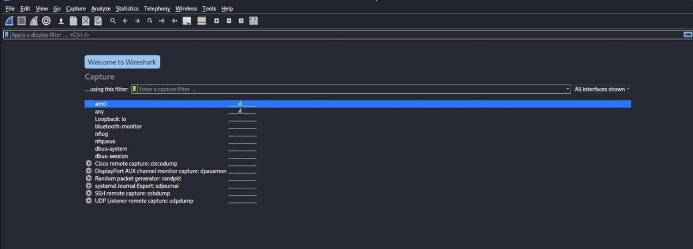When you open Wireshark, you see a screen that shows you a list of all of the network connections you can monitor. You also have a capture filter field, so you only capture the network traffic you want to see.
* Choose eth0, which is used for monitoring network such as [protocols ,](https://www.wikitechy.com/final-year-project/dotnet/server-hacking/what-is-protocol) sessions , packs and then select the shark tail symbol or double tap the eth0.
* 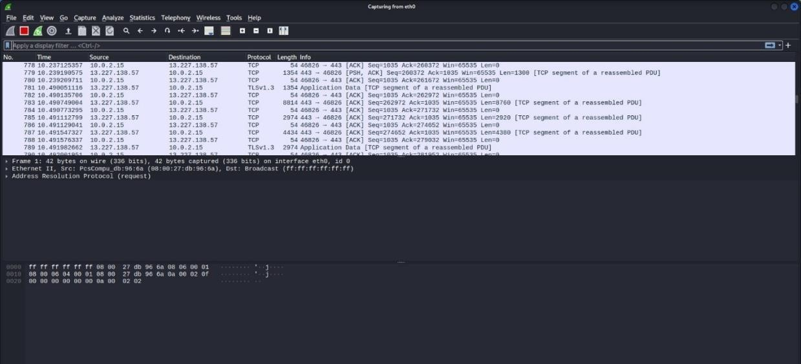Now Capturing will start which shows sender and receiver [IP address](https://www.wikitechy.com/tutorials/ethical-hacking/windows-hacking/how-to-find-the-ip-address-of-a-website) , it means trace router root, protocols and response time in milli seconds.
* The above arrow shows the packet content written in hexadecimal or the ASCII format. And the information above the packet content, are the details of the packet header.
* It will continue listening to all the data packets, and you will get much data. If you want to see a particular data, then you can click on the red button. The traffic will be stationary, and you can note the parameters like time, source, destination, the protocol being used, length, and the Info. To view in-depth detail, you can click on that particular address; a lot of the information will be displayed below that.
* Now Capturing will start which shows sender and receiver IP address, it means trace router root, protocols, and response time in milli seconds.

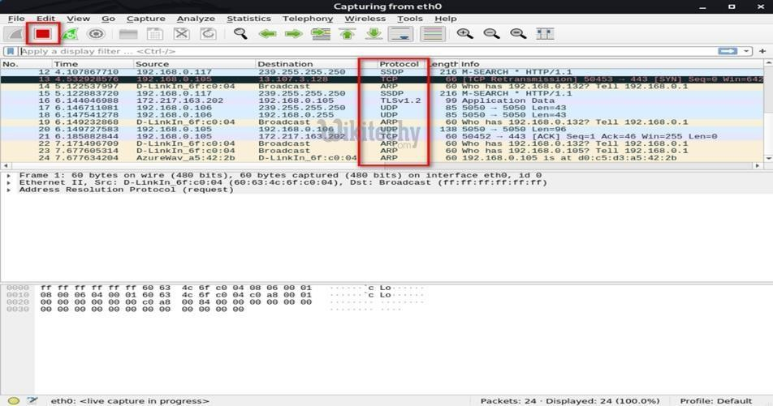

Wireshark shows you three different panes for inspecting packet data.

The Packet List, the top pane, is a list of all the packets in the capture. When you click on a packet, the other two panes change to show you the details about the selected packet.

You can also tell if the packet is part of a conversation. Here are some details about each column in the top pane:

* No.: This is the number order of the packet that got captured. The bracket indicates that this packet is part of a conversation.
* Time: This column shows you how long after you started the capture that this packet got captured. You can change this value in the Settings menu if you need something different displayed.
* Source: This is the address of the system that sent the packet.
* Destination: This is the address of the destination of that packet.
* Protocol: This is the type of packet, for example, TCP, DNS, DHCPv6, or ARP.
* Length: This column shows you the length of the packet in bytes.
* Info: This column shows you more information about the packet contents, and will vary depending on what kind of packet it is.
* There is a filter block below the menu bar, from where a large amount of data can be filtered. For example, if we apply a filter for HTTP, only the interfaces with the HTTP will be listed

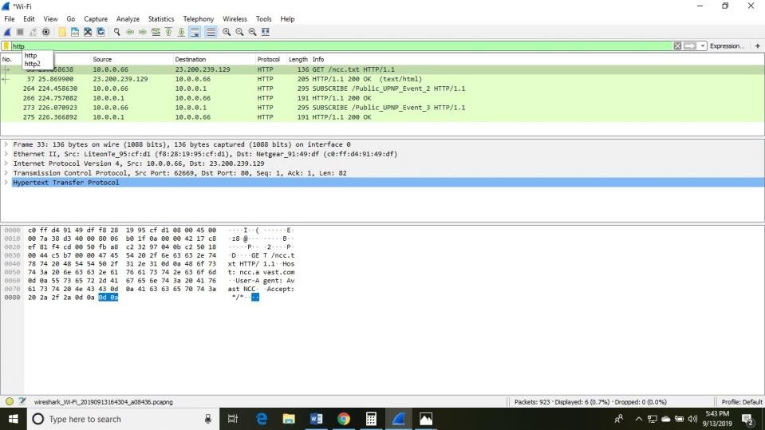

* For example if we open the adit localhost website of IP address 10.0.0.1 of port number 8090 and if we do the login with user name and password than it is captured in wireshark as it captures the packet so when we open the wireshark and filter it with http we can see a login http session so we right click on follow the stream than it can show the username and password which I entered in adit website. Now click the Html Form URL Encoded which is for user credentials are stored in URL encoded tag, then http web page login details are displayed.

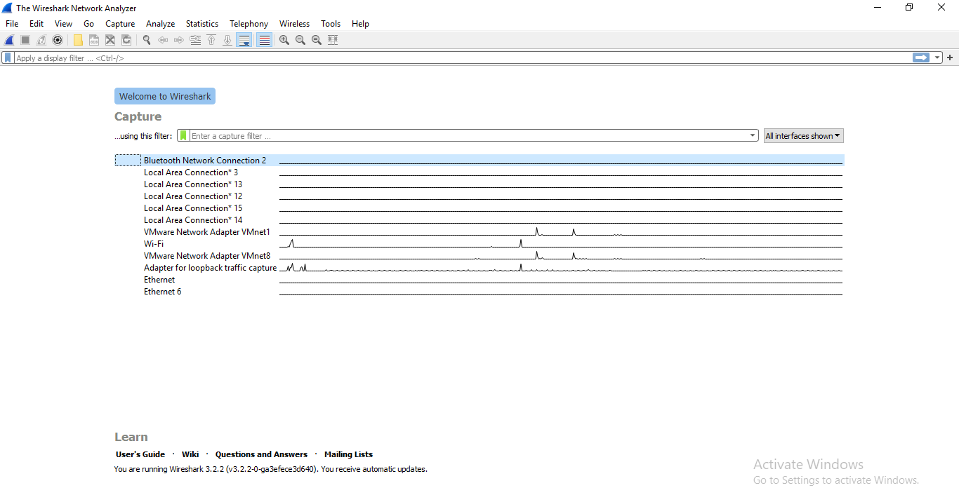

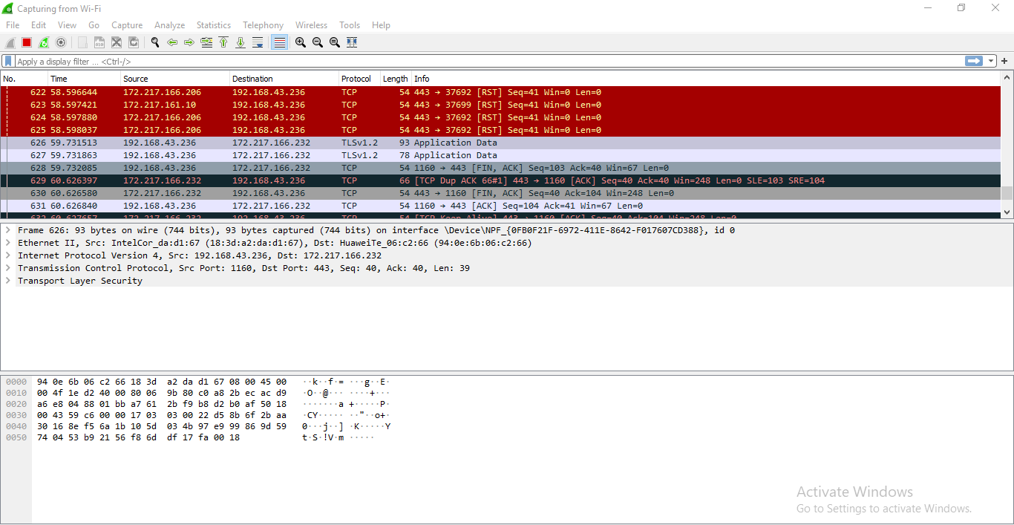

**PRACTICAL -4**

**Aim : Using open port information perform MITM(Man In The Middle) attack using arpspoof, urlsnarf, dsniff, dnsspoof.**

**1. Interruption**

**2. Interception**

**Man in the Middle Attack (MITM)**

* A man in the middle (MITM) attack is a general term for when a perpetrator positions himself in a conversation between a user and an application—either to eavesdrop or to impersonate one of the parties, making it appear as if a normal exchange of information is underway.
* The goal of an attack is to steal personal information, such as login credentials, account details and credit card numbers.
* Targets are typically the users of financial applications, SaaS businesses, e-commerce sites and other websites where logging in is required.



* These attacks are carried out through a two-step process known as data interception and decryption.
* Data interception entails an attacker intercepting a data transfer between a client and a server.
* The attacker tricks the client and the server into believing that they are exchanging information with each other, while the attacker intercepts the data, creates a connection to the real site and acts as a proxy to read and insert false information into the communication.

**1] Working of Interruption in MITM**

* It is the first step in the MITM attack.

1. When two parties communicate over a network, their communication is typically encrypted to ensure that only the intended recipient can read the data.
2. However, if an attacker is able to intercept the communication, they can decrypt the data and read it themselves.
3. In addition to reading the data, the attacker can also manipulate it before forwarding it on to the intended recipient. This manipulation can involve inserting malicious code or altering the data to achieve a specific outcome.
4. To the recipient, the communication appears to be normal, but in reality, it has been tampered with by the attacker.
5. The attacker can also inject their own data into the communication, posing as one of the legitimate parties. This can allow the attacker to gain access to sensitive information, such as login credentials or financial data.
6. The goal of the attacker is to remain undetected and to manipulate the communication without either party realizing that anything is wrong.
7. To protect against interruption-based MitM attacks, it's important to use secure communication protocols, such as HTTPS or SSL/TLS, and to avoid using unsecured public Wi-Fi networks. Additionally, using digital certificates and verifying the authenticity of SSL/TLS connections can help prevent MitM attacks.

In an interruption attack, a network service is made degraded or unavailable for legitimate use. They are the attacks against the availability of the network.

Examples of Interruption attacks :

* Overloading a server host so that it cannot respond.
* Cutting a communication line.
* Blocking access to a service by overloading an intermediate network or network device.
* Redirecting requests to invalid destinations.
* Theft or destruction of software or hardware involved.

**2] Working of Interception**

1. In a MitM attack, the attacker positions themselves between the two parties communicating on a network, intercepting the data being sent between them.
2. The attacker can intercept data through various means, such as Wi-Fi spoofing, DNS spoofing, and ARP spoofing.
3. Once the attacker has intercepted the communication, they can view the data being transmitted, including any sensitive information that the parties are exchanging.
4. The attacker can also manipulate the data or inject their own data into the communication, posing as one of the legitimate parties.
5. The goal of the attacker is to remain undetected and to manipulate the communication without either party realizing that anything is wrong.
6. Interception-based MitM attacks are a serious threat, especially in situations where sensitive information is being transmitted, such as online banking or e-commerce transactions.
7. To protect against interception-based MitM attacks, it's important to use secure communication protocols, such as HTTPS or SSL/TLS, and to avoid using unsecured public Wi-Fi networks. Additionally, using digital certificates and verifying the authenticity of SSL/TLS connections can help prevent MitM attacks.

An interception is where an unauthorized individual gains access to confidential or private information. Interception attacks are attacks against network the confidentiality objective of the CIA Triad.

Examples of Interception attacks:

1. Eavesdropping on communication.
2. Wiretapping telecommunications networks.
3. Illicit copying of files or programs.
4. Obtaining copies of messages for later replay.
5. Packet sniffing and key logging to capture data from a computer system or network.

Mitigate the attack :

**Using Encryption -** SSL, VPN, 3DES, BPI+ are deployed to encrypts the flow of information from source to destination so that if someone can snoop in on the flow of traffic, all the person will see is ciphered text.

**Traffic Padding -** It is a function that produces cipher text output continuously, even in the absence of plain text. A continuous random data stream is generated. When plaintext is available, it is encrypted and transmitted. When input plaintext is not present, the random data are encrypted and transmitted. This makes it impossible for an attacker to distinguish between tree data flow and noise and therefore impossible to deduce the amount of traffic.

**ARP Spoof**

* The actual ARP poisoning attack is redirecting the flow of packets and making it flow through our device.
* Here, we use a tool called arpspoof, which is part of the suite called **dsniff**. This suite contains several programs that can be used to launch MITM attacks.
* Here, we see how to use arpspoof tool to carry out ARP poisoning, which redirects the flow of packets through our device.
* Windows is the target device, and we are going to the ARP table.
* So, we will run **arp -a** on the Windows machine to see the ARP table.
* In the following screenshot, we can see that the IP address for the access point is 10.0.0.1, and we can see its MAC address is c0-ff-d4-91-49-df. It is stored in the ARP table:

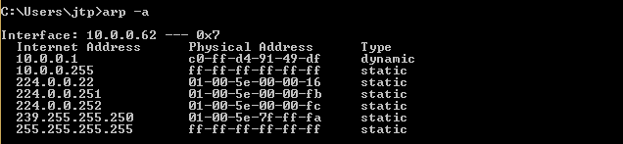

* We are connected now to the target network.
* We are going to use a tool arpspoof -i to choose our internet card which is wlan0.
* Then we are going to put the IP address of the target Window device which is 10.0.0.62.
* Then we are going to put the IP address for the access point, which is 10.0.0.1.
* We will tell the access point that the client IP address has our MAC address, so basically, we're going to tell the access point that we are the target client:

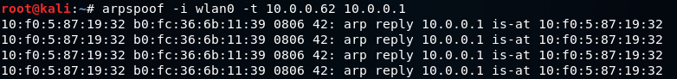

* After this, we're going to run arpspoof again, and instead of telling the access point that we are the target client, we are going to tell the client that we are the access point, so we're just going to flip the IPs:

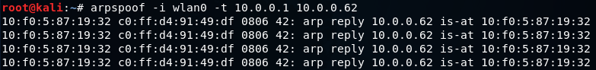

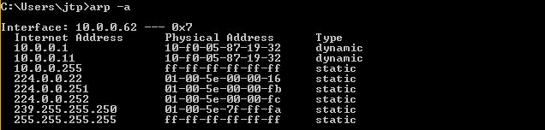

* Now, we are going to enable the IP forwarding.
* We do that so that when the packets flow through our device, they do not get dropped so that each packet that goes through our device gets actually forwarded to its destination.
* So, when we get a packet from the client, it goes to the router, and when a packet comes from the router, it should go to the client without being dropped in our device.
* So, we are going to enable it using this command:



* The window device now thinks that the attacker device is the access point, and whenever the window device tries to communicate with the access point, it is going to send all these requests to the attacker device.
* This will place our attacker device in the middle of the connection, and we will be able to read all the packets, modify them, or drop them.

**URLsnarf**

* URL snarf" is a computer network tool used to intercept and log URLs (Uniform Resource Locators) that are transmitted over a network.
* The tool is typically used by network administrators or security professionals to monitor network traffic and detect potential security threats.
* URL snarf works by capturing the data packets that are transmitted over the network and then filtering out any URLs contained within those packets.
* The tool then logs those URLs, providing the network administrator with a record of the web pages that were accessed by network users.
* While URL snarf can be a useful tool for monitoring network activity, it can also be used for malicious purposes.
* For example, an attacker could use URL snarf to intercept login credentials or other sensitive information that is transmitted over the network.
* It is important to note that using URL snarf without permission from the network owner is illegal and unethical.
* It is always best to obtain permission before using any network monitoring tools, and to use them only for legitimate purposes.

**Dsniff**

* "Dsniff" is a computer network tool that is used to intercept and analyze network traffic in real-time.
* It is commonly used by network administrators and security professionals to monitor network activity, detect potential security threats, and analyze network performance.
* Dsniff can be used to capture a wide range of network traffic, including emails, passwords, web pages, and other network data.
* The tool uses a variety of techniques to intercept this traffic, including ARP spoofing, DNS spoofing, and packet sniffing.
* Once it has intercepted network traffic, dsniff can be used to analyze and decode the captured data, allowing network administrators to identify potential security threats or performance issues.
* The tool can also be used to generate reports on network activity, making it easier for administrators to understand and manage their network infrastructure.
* While dsniff can be a useful tool for network monitoring and analysis, it can also be used for malicious purposes.
* For example, an attacker could use dsniff to intercept sensitive information, such as login credentials or credit card numbers, that is transmitted over the network.
* As with any network monitoring tool, it's important to use dsniff responsibly and with permission from the network owner. Using dsniff or any other network monitoring tool without permission is illegal and unethical.

**Dnsspoof**

* "DNSSpoof" is a computer network tool that is used to intercept and modify DNS (Domain Name System) requests and responses.
* The tool is commonly used by network administrators and security professionals to monitor and control network traffic, detect potential security threats, and enforce network policies.
* DNSSpoof works by intercepting DNS requests and responses and modifying them to redirect traffic to a different IP address.
* This can be useful for a variety of purposes, such as blocking access to malicious websites, redirecting traffic to a different server for load balancing, or enforcing network policies.
* For example, a network administrator could use DNSSpoof to block access to a known malicious website by intercepting DNS requests for that website and redirecting them to a local web server that displays a warning message instead of the actual website.
* While DNSSpoof can be a useful tool for network administration and security, it can also be used for malicious purposes. For example, an attacker could use DNSSpoof to redirect users to a fake website that mimics a legitimate website in order to steal login credentials or other sensitive information.
* It is important to note that using DNSSpoof without permission from the network owner is illegal and unethical.
* It is always best to obtain permission before using any network monitoring or control tools, and to use them only for legitimate purposes.

**PRACTICAL -5**

**Aim : Understand the concept of firewall and configure the Statefull Packet Inspection(SPI) firewall IPTABLES.**

**Firewall**

* A firewall can be defined as a special type of network security device or a software program that monitors and filters incoming and outgoing network traffic based on a defined set of security rules.
* It acts as a barrier between internal private networks and external sources (such as the public Internet).
* The primary purpose of a firewall is to allow non-threatening traffic and prevent malicious or unwanted data traffic for protecting the computer from viruses and attacks.
* A firewall is a cybersecurity tool that filters network traffic and helps users block malicious software from accessing the Internet in infected computers.

**Working of Firewall**

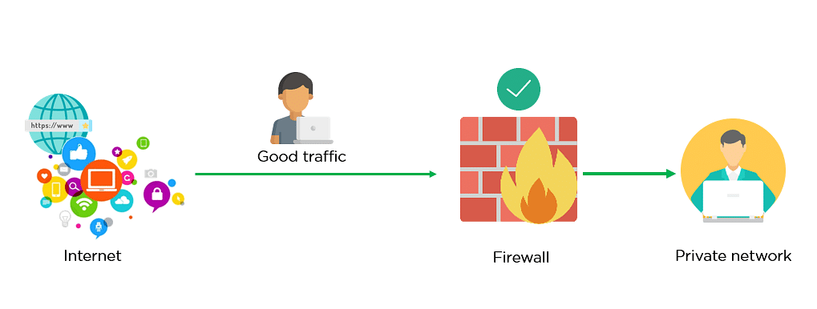

* A firewall system analyzes network traffic based on pre-defined rules. It then filters the traffic and prevents any such traffic coming from unreliable or suspicious sources.
* It only allows incoming traffic that is configured to accept.
* Typically, firewalls intercept network traffic at a computer's entry point, known as a port. Firewalls perform this task by allowing or blocking specific data packets (units of communication transferred over a digital network) based on pre-defined security rules.
* Incoming traffic is allowed only through trusted IP addresses, or sources.

**Statefull packet Inspection**

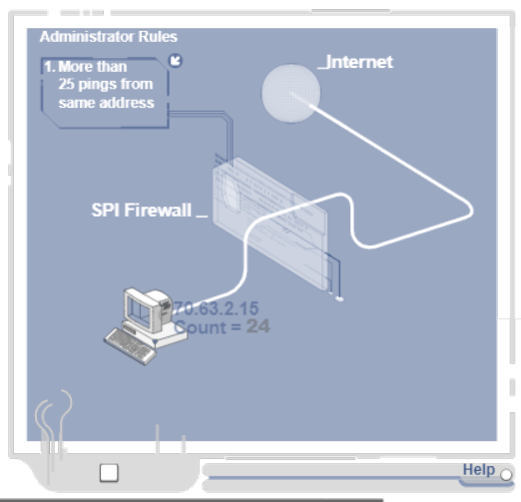

* Stateful Packet Inspection (SPI) Firewalls, also known as dynamic packet filtering, improves static packet filtering by using a "state table" to keep track of legitimate Internet service requests.
* SPI firewalls work by only allowing data through that comes from known and active connections. Any other data is rejected.
* SPI firewalls record attributes including the requesting (egress) client's IP and port addresses, handshake (SYN-ACK-ACK) statuses, and egress routes. This group of attributes is collectively known as the state of the connection.
* This firewall matches ingress traffic against these outgoing requests to ensure that each response is expected.
* Stateful packet inspectors typically have the same features as static packet filters, but they are able to view more of the network packet to determine whether to allow or block traffic.
* Again, ingress packets that do not meet the criteria established by the SPI are discarded.
* Stateful packet inspectors can increase the performance of some networks because they allow fewer packets to pass.

**Iptables Basics** :iptables is made up of some basic structures known as tables, chains, and targets Let us look at each of these.

**Tables**

Tables are a iptables construct that defines categories of functionality such as packet filtering or NAT.

There are four tables: FILTER, NAT, MANGLE and RAW. Filter is the default table if none other is specified. NAT is used to rewrite the source and/or destination of packets.

MANGLE is used for packet alteration such as modifying the TCP header. RAW is used for configuring exemptions from connection tracking.

**Chains**

Each table has its own built-in chains and the user can define their own chains. Chains are lists of rules within a table. For our purposes here, the most important chains are

INPUT, OUTPUT and FORWARD.

**INPUT**

This chain is for packets destined for the local system

**OUTPUT**

This chain is for packets leaving the local system

**FORWARD**

This chain is for packets being routed through the local system

**MATCH**

A MATCH is where a packet meets the condition established by the rule. iptables then processes the packet according to the action in the rule.

**TARGETS**

iptables supports a set of targets that trigger an action when the packet meets the condition of a rule. The most important of these are ACCEPT (allow the packet to pass), DROP (drop the packet), LOG, REJECT (drop the packet and send back an error) and RETURN.

**Steps to Configure**

##### Step #1: Installing Iptables

Iptables comes installed on nearly every Linux and *nix system, but if for some reason your system doesn't have iptables tables installed, you can download it from the repository. **kali > sudo apt install iptables**

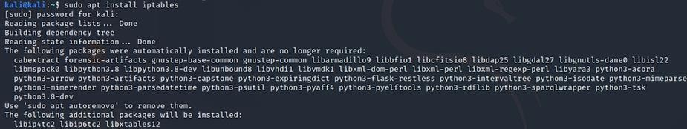

##### Step #2: Configuring the Default Policy

Before we begin configuring our iptables, we must first decide what will be our default policy. In other words, what should the firewall do to packets that do not match any rule.

To see the default policy on your policy chains, simply enter; **kali**

##### > sudo iptables -L

##### 

##### Step #3: Create Some rules

Next, let's create some rules. Let's assume that you want to block any packets coming from IP address 192.168.1.102. To create this rule, we simply do the following;

**-A** this appends this rule to the chain

**INPUT** looks to match on packets coming to the local system

**-s** sets the source address of the packets

**-j** sets the target in this case DROP

* We can do the same for the entire sub-network by using CIDR notation or 192.168.1.0/24



* If we want to DROP packets destined for a particular port, we can use -p option followed by the protocol (tcp) and the --dport (destination port) followed by the port (ssh).



* If we wanted to accept connections to the website [www.amazon.com,](http://www.amazon.com/) we could build a rule that ACCEPTs outgoing connection (OUTPUT) over the TCP protocol (-p tcp) tp [amazon.com](http://amazon.com/) (-d amazon.com) **kali > sudo iptables -A OUTPUT -p tcp -d amazon.com -j ACCEPT**



* It's important to note that iptables will do a DNS lookup only at the time of the creation of the rule. If the IP address changes, the rule will become ineffective. For this reason, it is preferable to use the IP address of the domain.

If we wanted to block access to any other websites, we could create the following two rules;

##### kali > sudo iptables -A OUTPUT -p tcp --dport 80 -j DROP kali

**> sudo iptables -A OUTPUT -p tcp --dport 443 -j DROP**



* The order of these rules is critical. iptables will search the rules until it finds a match. This means that if the last 2 rules, dropping port 80 and 443, were placed before the domain rule, the user would never be able to reach [amazon.com](http://amazon.com/) as the drop rules would match before reaching the domain rule.
* 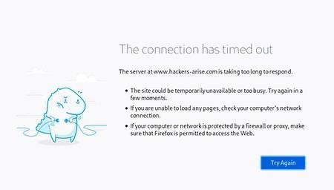So when the local system attempts to connect to amazon.com[,](http://hackers-arise.com/) they are blocked and the browser times out as seen below.
* Finally, we can view our table by using the -L or list option

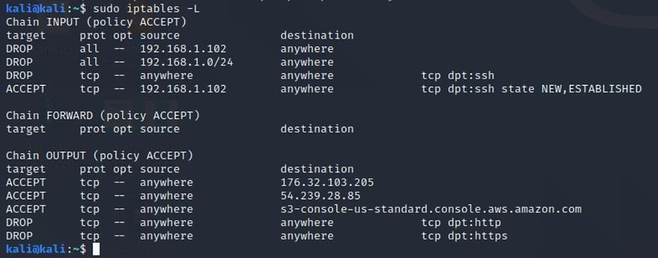

* To delete a a table and start over, we can flush (-F) the table

**PRACTICAL -6**

**Aim : BASIC configuration of Intrusion Detection System: Snort.**

**Intrusion Detection System**

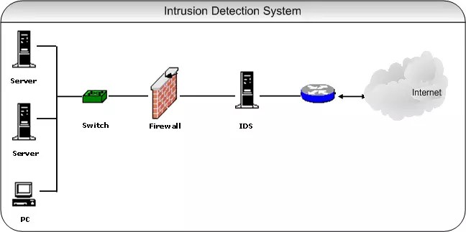

* A system called an intrusion detection system (IDS) observes network traffic for malicious transactions and sends immediate alerts when it is observed.
* It is software that checks a network or system for malicious activities or policy violations.
* Each illegal activity or violation is often recorded either centrally using a SIEM system or notified to an administration. IDS monitors a network or system for malicious activity and protects a computer network from unauthorized access from users, including perhaps insiders.
* The intrusion detector learning task is to build a predictive model (i.e., a classifier) capable of distinguishing between ‘bad connections’ (intrusion/attacks) and ‘good (normal) connections.’

**Working of IDS**

* An IDS (Intrusion Detection System) monitors the traffic on a computer network to detect any suspicious activity.
* It analyzes the data flowing through the network to look for patterns and signs of abnormal behavior.
* The IDS compares the network activity to a set of predefined rules and patterns to identify any activity that might indicate an attack or intrusion.
* If the IDS detects something that matches one of these rules or patterns, it sends an alert to the system administrator.
* The system administrator can then investigate the alert and take action to prevent any damage or further intrusion.

**Snort**



* SNORT is a network-based intrusion detection system which is written in C programming language.
* It was developed in 1998 by Martin Roesch. Now it is developed by Cisco. It is free open-source software.
* It can also be used as a packet sniffer to monitor the system in real time.
* The network admin can use it to watch all the incoming packets and find the ones which are dangerous to the system.
* It is based on library packet capture tool.
* The rules are easy to create and implement and it can be deployed in any kind of operating system and any kind of network environment.
* The main reason of the popularity of this IDS over others is that it is a free-to-use software and open source because of which any user can be able to use it as the way he wants.

**Features of Snort**

1. Real-time traffic monitor
2. Packet logging
3. Analysis of protocol
4. Content matching
5. OS fingerprinting
6. Can be installed in any network environment.
7. Creates logs
8. Open Source
9. Rules are easy to implement

**Different modes in SNORT**

1. Sniffer Mode – To print TCP/IP header use command ./snort -v

To print IP address along with header use command ./snort -vd

1. Packet Logging – To store packet in disk you need to give path where you want to store the logs.

For this command is./snort -dev -l ./SnortLogs.

1. Activate network intrusion detection mode – To start this mode use this command ./snort -dev -l ./SnortLogs -h 192.127.1.0/24 -c snort.conf

**Rules in SNORT**

There are 3 types of rules in SNORT, those are

1. Alert Rules: This uses the alert technique to produce notifications.
2. Logging Rules: It logs each individual alert as soon as it is generated.
3. Pass Rules: If the packet is deemed malicious, it is ignored and dropped.

**Usage of SNORT**

1. Packet Sniffing: The way traffic is being transmitted can be thoroughly examined by gathering the individual packets that travel to and from devices on the network.
2. Generates Alerts: It generates warnings based on the configuration file’s rules when it discovers unusual or malicious activity, the possibility of a vulnerability being exploited, or a network threat that compromises the organization’s security policy.
3. Debug Traffic: After the traffic has been logged, any malicious packets and configuration problems are checked.

**Configuration of IDS in SNORT**

* Like all Linux commands and applications, Snort also has the help of the command line, which can be invoked by using the following code:

kali > sudo snort –-help

* I have highlighted a few switches from the Help section of Snort:

-c gives us the location of the Snort rules and tells it to use its rules. They are the signature against which the new packets are verified.

-d tells Snort to show the application layer of data.

–e displays the Data Link layer of information, which contains the MAC address of the system.

–i allows the user to designate the interface we want to use. By default, Snort uses eth0.

–k allows the users to define how they want to store the details of the data capture performed by Snort.

-v is like in most of the programs — verbose, providing all the information.

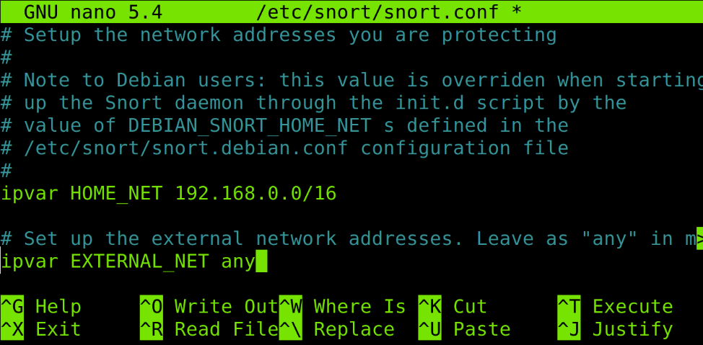

**Starting Snort**

* Let us get to know some of the basic switches of Snort, by first running iy. What makes Snort fabulous is that it can be run as a sniffer, packet logger, or even as a NIDS. In this article, we will look at Snort as a packet sniffer and NIDS.

|  |
| --- |
| kali > sudo snort -vde |

* To run Snort in packet dump mode, use the following command:
* The output we get is pretty self-explanatory (Figures 2). For using Snort as a NIDS, we need to instruct Snort to include the configuration file and rules.
* Generally, we can find the conf file at /etc/snort/snort.conf and that file will point to Snort rules. We need to give the -c switch and then the location.

|  |
| --- |
| kali > sudo snort -vde -c /etc/snort/snort.conf |

We can also customise the rules to suit our needs.

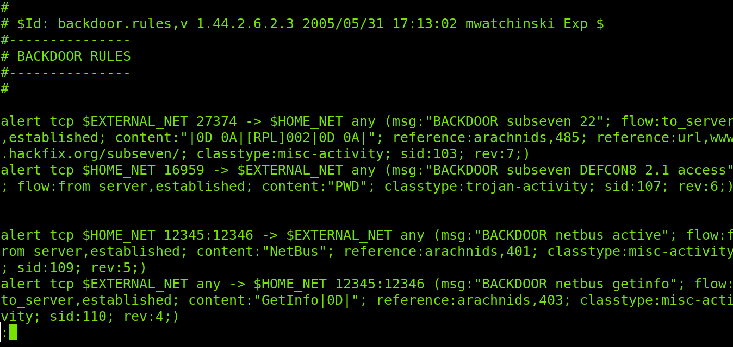

**Snort — rules and configuration**

* Like all general Linux applications, Snort is configured via a conf file, which can be opened as a simple text file. Edit this text file, restart the application and we have a new working configuration.
* Before going any further, let’s take a brief look into the syntax of Snort rules.
* Snort rules must be contained in a single line or we can use the multi-line character \. For example:

log tcp !x.x.x/xx     OR  log tcp !x.x.x/xx any -> xxx \ (msg: “some command”)

* All rules should contain a rule header (which identifies the actions) and rule options (which identify the rule’s alert messages).
* The rules must describe situations like a violation of the security policy of the company, or correctly detect the exploitable vulnerabilities.
* There are three kinds of rules in Snort:
* Alert rules: This generates alerts using the alert method.
* Log rules: Upon generation of any alert, it logs that specific alert.
* Pass rules: Ignores the packet if deemed malicious and drops it.
* Now we can move on to the configuration file, which can be opened using the following command:

|  |
| --- |
| * kali > mousepad /etc/snort/snort.conf |

* In the Snort configuration file, we may see nine sections, as shown in Figure 4.
* For the most basic configuration, we will address only Sections 1, 6 and 7 as seen in Figure 5, 6, 7.

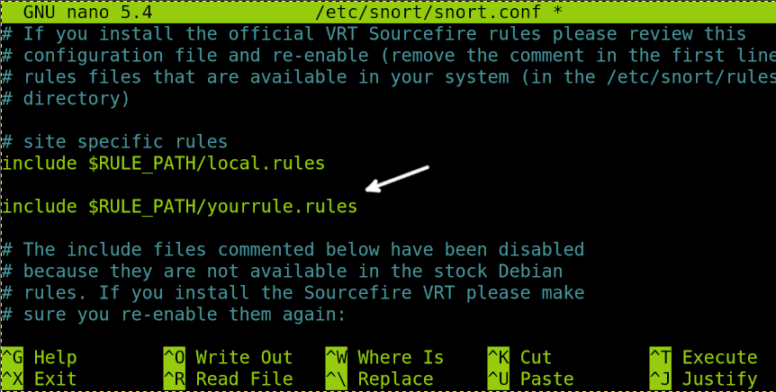

Setting variables

* In the screenshot in Figure 5, we can see the highlighted line ‘ipvar HOME_NET’. This variable denotes the network is protected. ‘HOME_NET’ is the variable name to which the IP address is assigned. This can be a single IP address, a list of IP addresses, or a subnet in CIDR notation, or even can be left as any.

Checking the output

* Using Ctrl+F, we then move on to output plugins (Figure 6). By default, Snort sends the output in log format. But if we want, we can comment out that line (unified2) and uncomment the bottom line (log_tcpdump), enabling the output in tcpdump format, which is saved in the /var/log/snort directory.

Disable rules

* Depending on your enterprise, we may need to change the rules that Snort relies upon, and customise them in Section 7, as shown in Figure 7.
* To not let Snort use a given set, simply comment out the include part.
* After making any change, simply save the file and test the configuration using the -T switch.

|  |
| --- |
| kali > sudo snort -T -c  /etc/snort/snort.conf |

**PRACTICAL -7**

**Aim : Network vulnerability assessment using OpenVAS/Necuss Framework.**

**Network Vulnerability Assessment**

* A vulnerability assessment is a process that helps review and analyze endpoint and device networks for security issues.
* The assessment may detect network flaws and holes in the network that could leave an opportunity for hackers to exploit.
* A network vulnerability should also be performed on an ongoing basis as new threats arise and hackers find additional ways to break into systems.

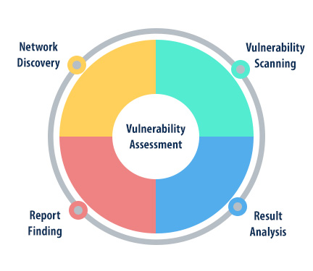

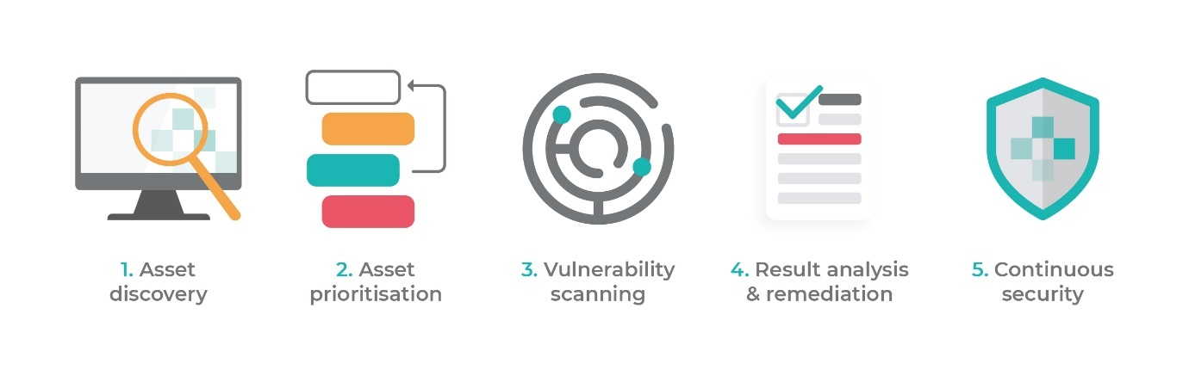

**STEPS TO CONFIGURE AND RUN OPEN VAS IN KALI LINUX**

**1) Installing Openvas on Kali Linux**

* To install Openvas and its dependencies on our Kali Linux system run the following command:

sudo apt update

sudo apt upgrade -y

sudo apt dist-upgrade -y

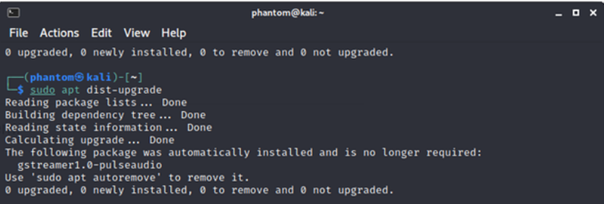

sudo apt install openvas

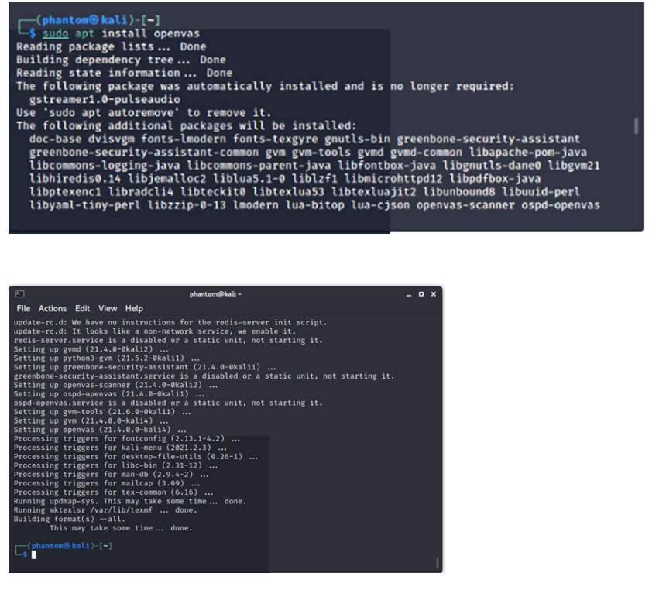

* The next step is to run the installer, which will configure OpenVAS and download various network vulnerability tests (NVT) or signatures. Due to many NVTs (50.000+), the setting process may take some time and consume a lot of data.
* In the test setup we used for this tutorial, the complete setup process took 10 minutes, which is not bad.
* Run the following command to start the setup process:

gvm-setup

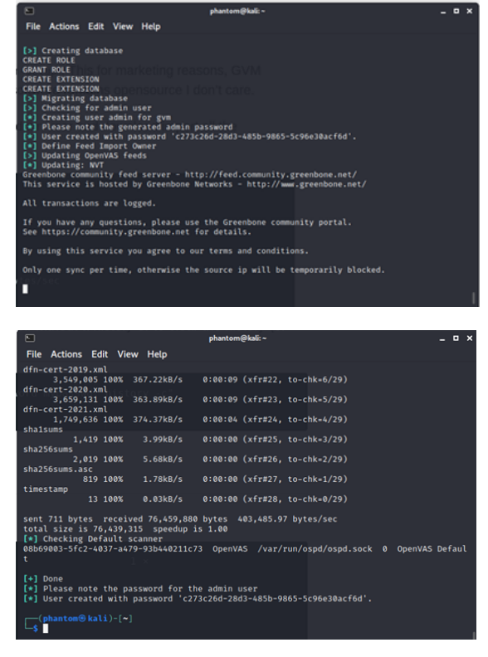

* After the configuration process is complete, all the necessary OpenVAS processes will start and the web interface will open automatically.
* The web interface is running locally on port 9392 and can be accessed through <https://localhost:9392>.
* OpenVAS will also set up an admin account and automatically generate a password for this account which is displayed in the last section of the setup output.

**2) Verify the Installation**

* You can verify your installation with.

gvm-check-setup

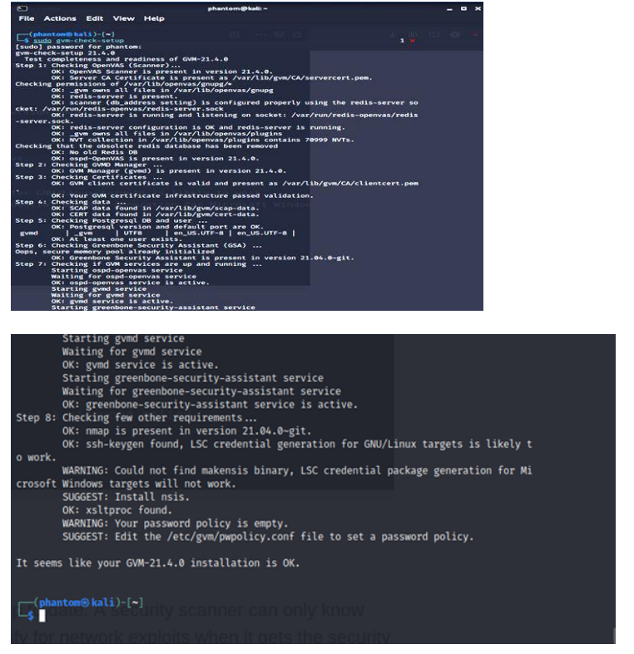

**3) Password Resetting**

* You can change the admin password sing the following commands:

gvmd --user=admin --new-password=passwd;

* The next step is to accept the self-signed certificate warning and use the

automatically generated admin credentials to login on to the web interface:

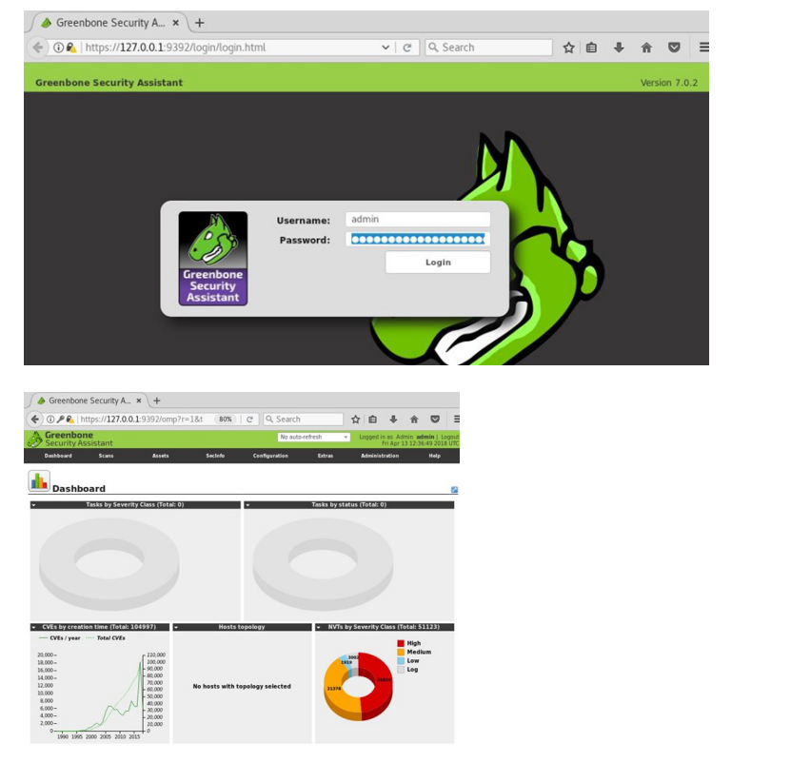

sudo gvm-start

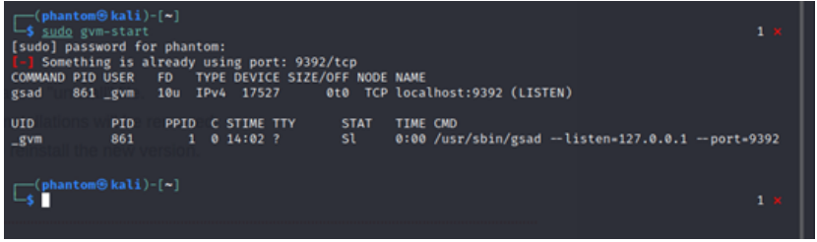

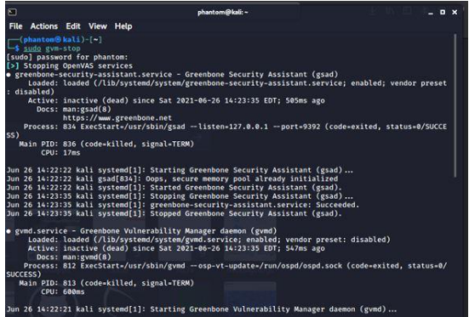

* *Note: To create a new user :

sudo runuser -u _gvm -- gvmd --create-user=admin2 --new-password=12345

* To change the password of the existing user:

sudo runuser -u _gvm -- gvmd --user=admin --new-password=new_password

**4) Configuration for New Target**

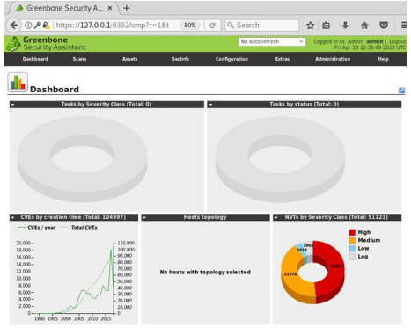

**5) Scheduling the scan Process**

* Expand the car to scan and> start the task of creating a scan task for

the managed computer.

* Creating a Task

To create a custom task, navigate to the star icon in the upper right corner of ` the taskbar and select New task.

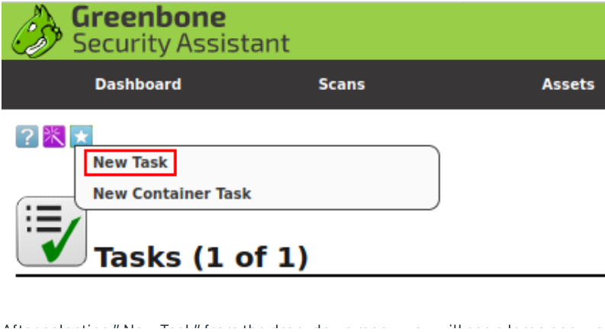

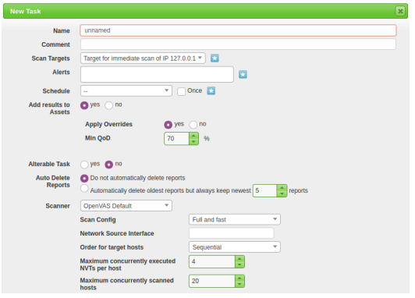

* For this task, we’ll be specializing only in the Name, Scan Targets, and Scanner Type,and Scan Config. In later tasks, we will be focusing on the opposite choices for additional advanced configuration and implementation/automation.

1. Name: permits North American country to line the name the scan are going to be referred to as inside OpenVAS

2. Scan Targets: The targets to scan, can embrace Hosts, Ports, and Credentials. To make a brand new target you may follow another pop-up, this can be lined later during this task.

3. Scanner: The scanner to use by default will use the OpenVAS design but you’ll be able to set this to any scanner of your selecting within the settings menu.

4. Scan Config: OpenVAS has seven totally different scan sorts you can choose fromcand can be used supported however you’re aggressive or what info you wish to gather from your scan.

**6) Scoping a new target**

* To scope a new target, navigate to the star icon next to Scan Targets.

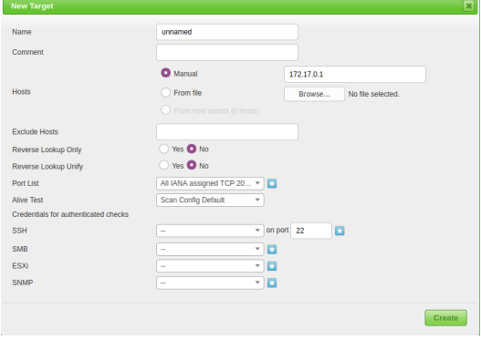

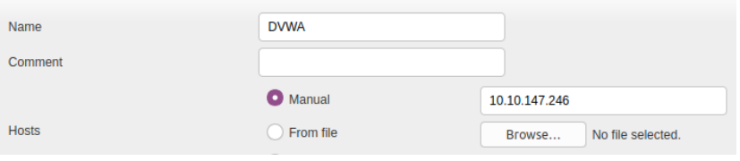

* To run the task, navigate to the run icon within the operation.

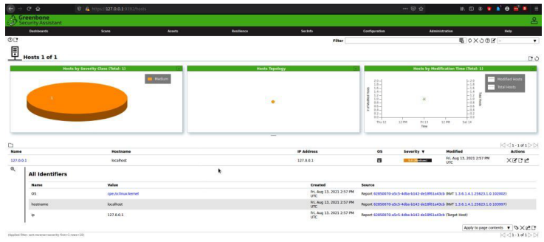

**7) Additional Features**

Allow adding common parameters to OpenVAS:

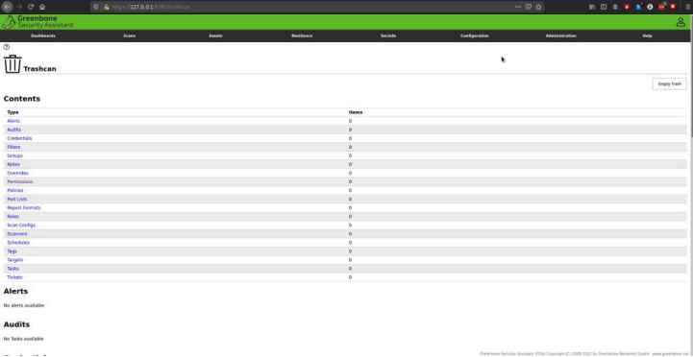

Administration

As the name suggests, you can manage passwords, users, etc.:

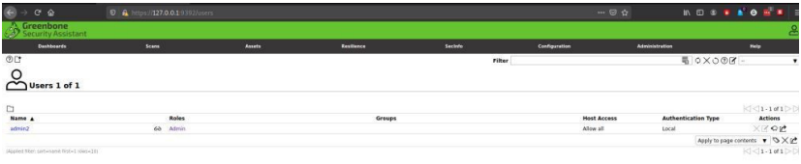

**PRACTICAL -8**

**Aim : Demonstrate automated SQL injection with SqLMap Or OWASP Juice Shop.**

**SQL Injection**

* SQL injection is a technique used to extract user data by injecting web page inputs as statements through SQL commands. Basically, malicious users can use these instructions to manipulate the application’s web server.

1. SQL injection is a code injection technique that can compromise your database.
2. SQL injection is one of the most common web hacking techniques.
3. SQL injection is the injection of malicious code into SQL statements via web page input.

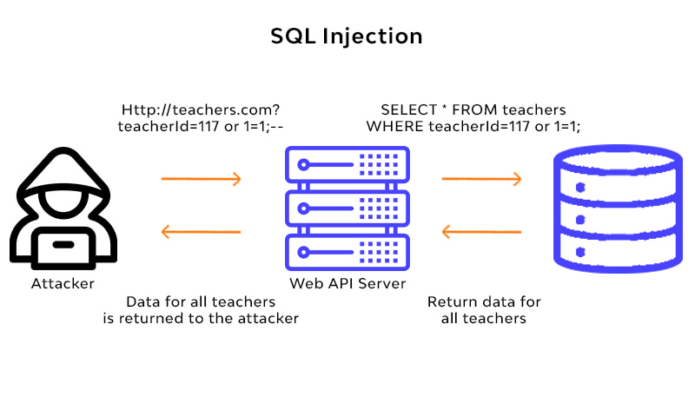

**Types of SQL injection**

SQL injections typically fall under three categories: In-band SQLi (Classic), Inferential SQLi (Blind) and Out-of-band SQLi. You can classify SQL injections types based on the methods they use to access backend data and their damage potential.

**1) In-band SQLi**

The attacker uses the same channel of communication to launch their attacks and to gather their results. In-band SQLi’s simplicity and efficiency make it one of the most common types of SQLi attack. There are two sub-variations of this method:

* **Error-based SQLi**—the attacker performs actions that cause the database to produce error messages. The attacker can potentially use the data provided by these error messages to gather information about the structure of the database.
* **Union-based SQLi**—this technique takes advantage of the UNION SQL operator, which fuses multiple select statements generated by the database to get a single HTTP response. This response may contain data that can be leveraged by the attacker.

**2) Inferential (Blind) SQLi**

The attacker sends data payloads to the server and observes the response and behavior of the server to learn more about its structure. This method is called blind SQLi because the data is not transferred from the website database to the attacker, thus the attacker cannot see information about the attack in- band.

Blind SQL injections rely on the response and behavioral patterns of the server so they are typically slower to execute but may be just as harmful. Blind SQL injections can be classified as follows:

* **Boolean**—that attacker sends a SQL query to the database prompting the application to return a result. The result will vary depending on whether the query is true or false. Based on the result, the information within the HTTP response will modify or stay unchanged. The attacker can then work out if the message generated a true or false result.
* **Time-based**—attacker sends a SQL query to the database, which makes the database wait (for a period in seconds) before it can react. The attacker can see from the time the database takes to respond, whether a query is true or false. Based on the result, an HTTP response will be generated instantly or after a waiting period. The attacker can thus work out if the message they used returned true or false, without relying on data from the database.

**3) Out-of-band SQLi**

The attacker can only carry out this form of attack when certain features are enabled on the database server used by the web application. This form of attack is primarily used as an alternative to the in-band and inferential SQLi techniques.

Out-of-band SQLi is performed when the attacker can’t use the same channel to launch the attack and gather information, or when a server is too slow or unstable for these actions to be performed. These techniques count on the capacity of the server to create DNS or HTTP requests to transfer data to an attacker.

**Demonstration using OWASP Juice Shop.**

1. Open the official OWASP juice shop website with URL: <https://owasp.org/www-project-juice-shop/>

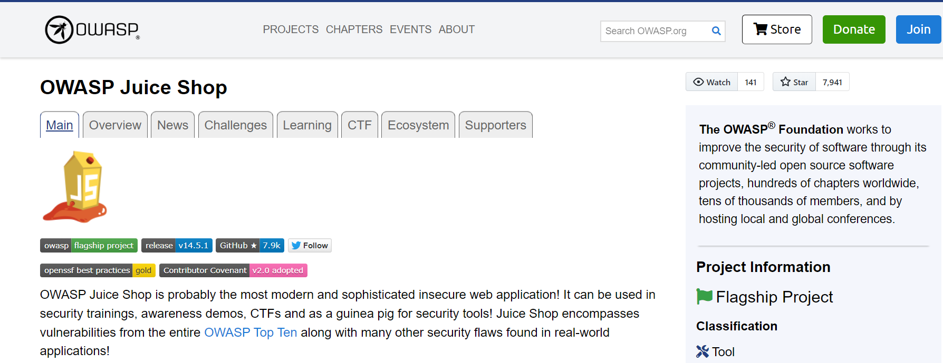

1. Find the link of “Online Demo” in the Documentation section:

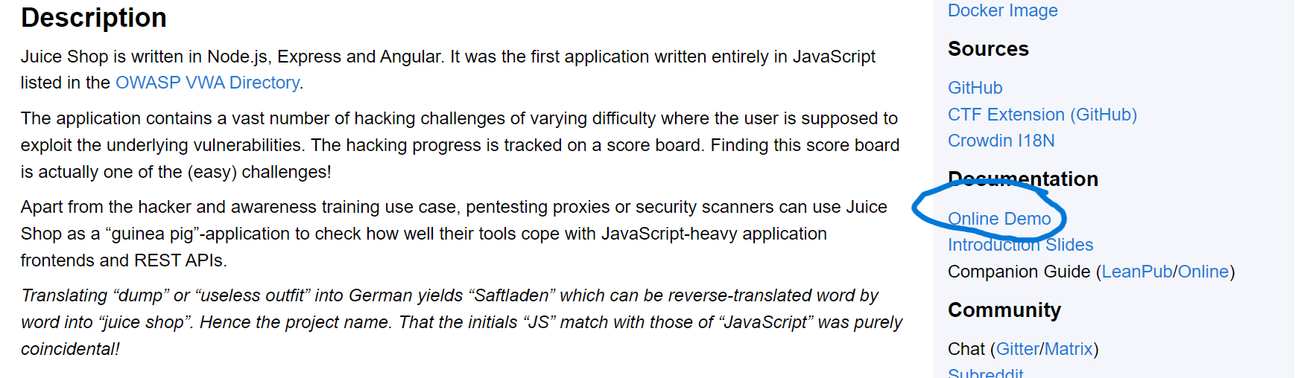

1. The following window will be displayed:

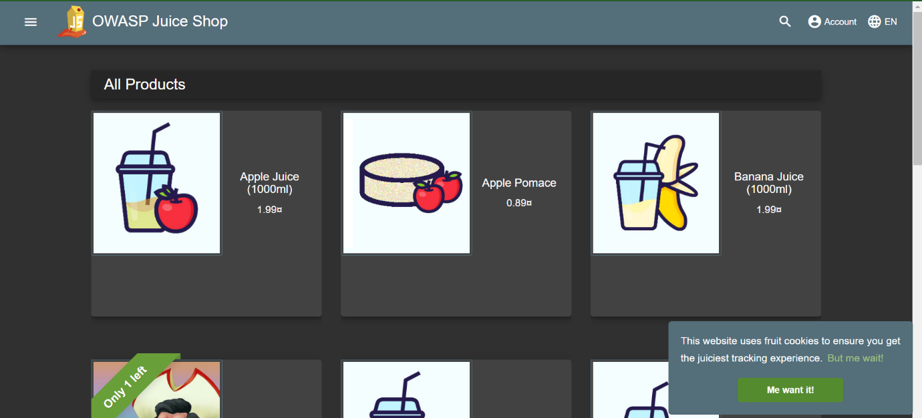

1. Click on “Account” and click on Login:

In the “Email” section, write the following SQL Query from inside the brackets:

***(‘ or ‘1’=’1’ -- )***

We can write anything in the password section.

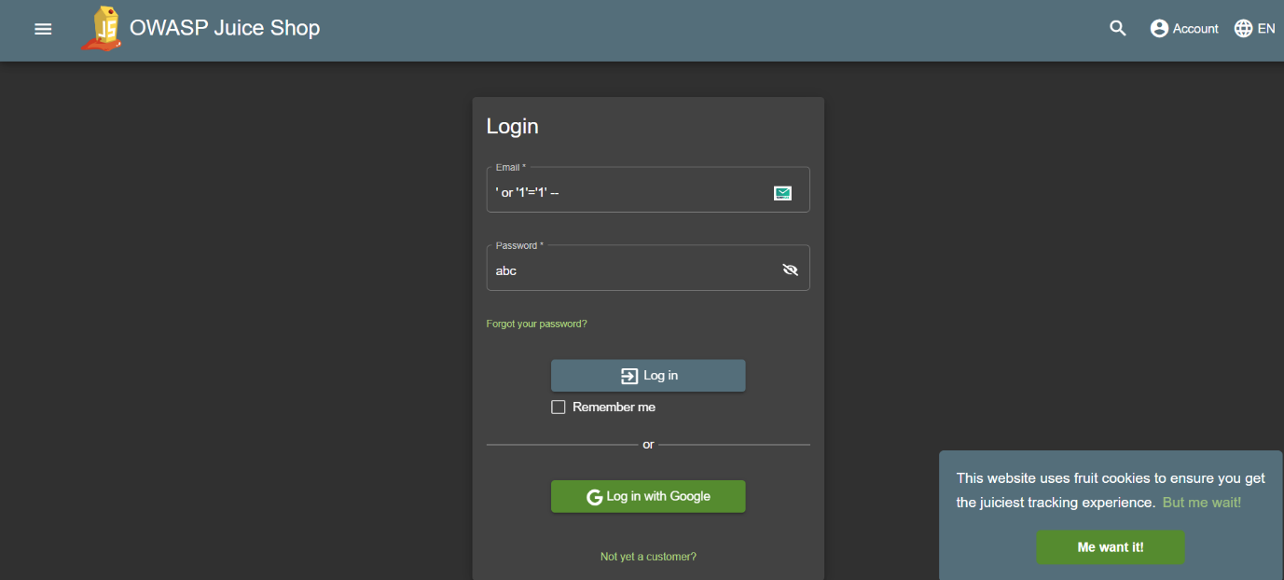

And click Log in

1. Now, you should be logged in to the web application without knowing the username or the password, that too with ADMIN privileges.

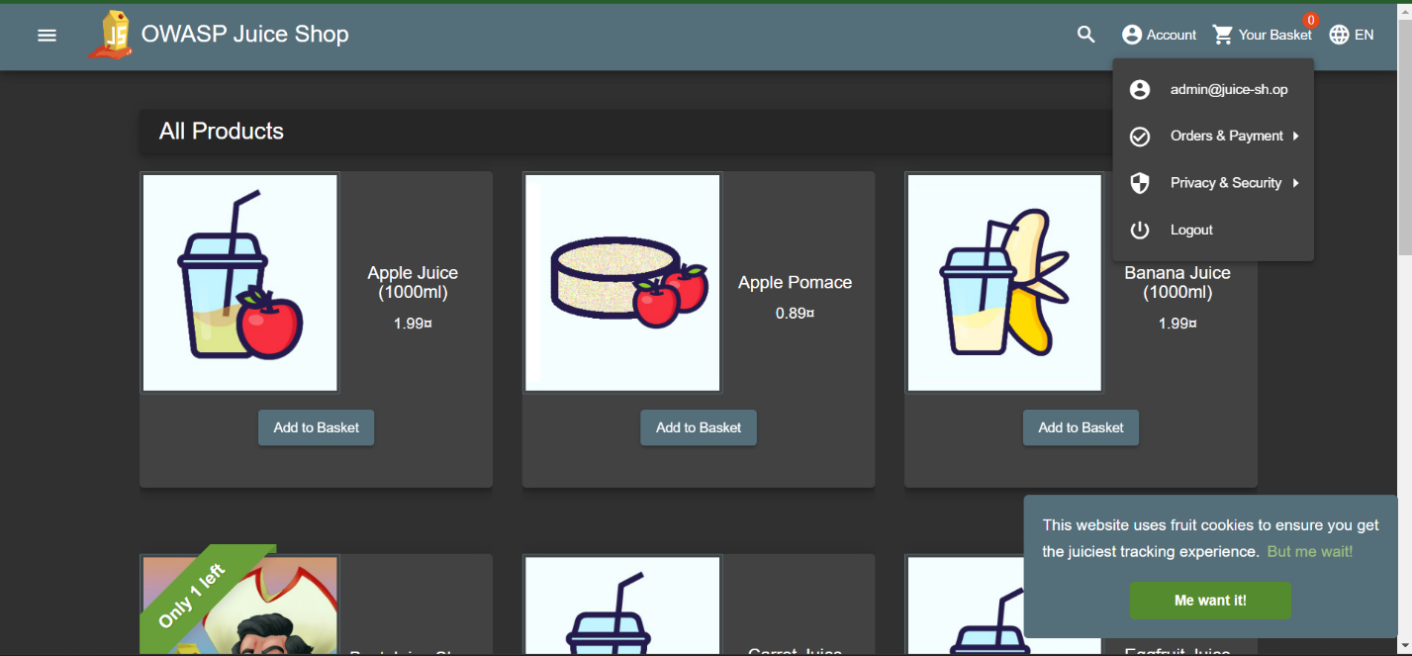

Now, after being logged in, we can perform any task as we are having administrative rights to the web application.

**PRACTICAL -9**

**Aim : Demonstrate Application Injection using Zed Attack Proxy.**

**Zed Attack Proxy**

* Zed Attack Proxy is an open-source security software written in Java programming language and released in 2010. It is used to scan web applications and find vulnerabilities in it.
* It was started as a small project by the Open Web Application Security Project (OWASP) and now it is the most active project maintained by thousands of individuals around the globe.
* It is available for Linux, Windows, and mac in 29 languages. It can also be used as a proxy server like a burp suite to manipulate the request including the HTTPS request.
* Daemon mode is also present in it which can later be controlled by REST API.

**Features of Zed Attack Proxy -OWASP**

* Passive Scanner
* Automated Scanner
* Proxy Server
* Port Identification
* Directory Searching
* Brute Force Attack
* Web Crawler
* Fuzzer

**Use of Zed Attack Proxy**

-Zed Attack Proxy is used to detect vulnerabilities present on any web server and try to remove them. Here is some big vulnerability that could be present in the web server:

* SQL injection
* Cross-site scripting (XSS)
* Broken access control
* Security miss-configuration
* Broken authentication
* Sensitive data exposure
* Cross-site request forgery (CSRF)
* Using components with known vulnerabilities.

**Demonstration/Practical**

**Step1:** Go to the Foxy Proxy website: https://addons.mozilla.org/enUS/firefox/addon/foxyproxy- standard/.

**Step 2:** Click “Continue to download.”

**Step 3:** Click “add to Firefox.”

**Step 4:** Firefox should prompt you to install Foxy Proxy. Firefox will need to be restarted at this point.

The steps for Automatic SQL Injection in Web Applications using ZED Attack Proxy are as follow:

1. Launch Jx Browser by clicking on the highlighted icon.

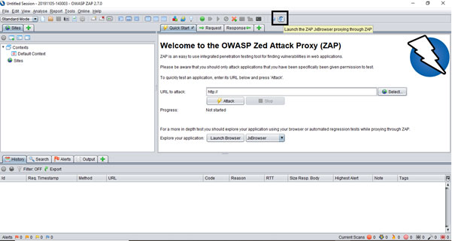

Jx Browser’s GUI is as given:

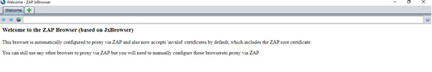

1. Put the URL of the Application that we need to attack in the address bar and hit the enter button.

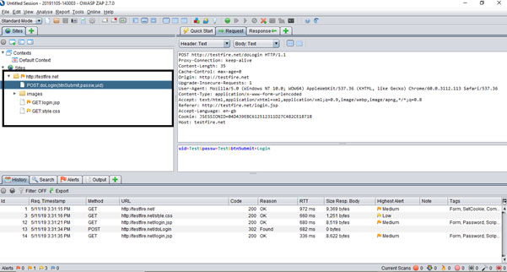

1. Observe network traffic, which, accessed via Jx Browser, captured in the ZAP tool.



1. Now find out the Post method inside the login API.

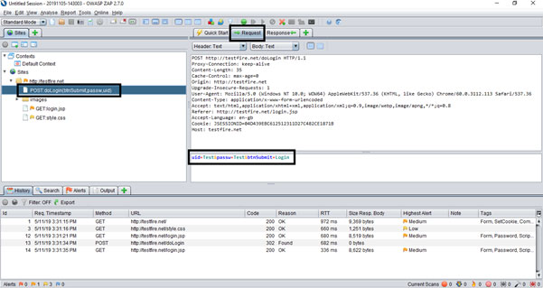

1. Now we will use ‘Fuzz’ functionality from ZAP, which is provided in the Attack section.

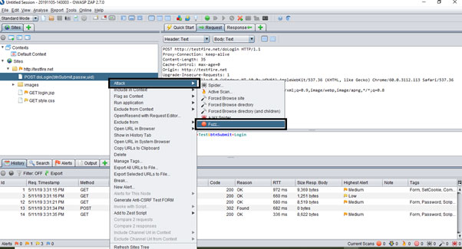We need to right click on login API call and need to select Fuzz option as below –

1. Select uid and click on ‘Add’.

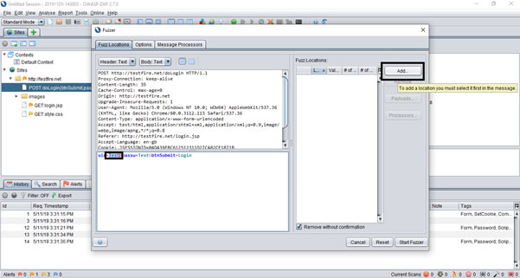

1. 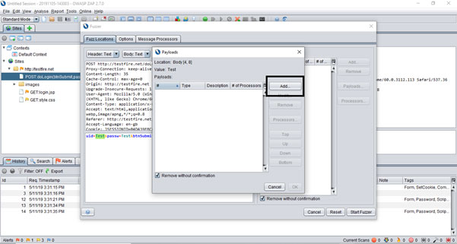Now Payload window opens, click on ‘Add’.
2. Select ‘File Fizzers’ from Type dropdown and expand the 3rd Then expand ‘Injections’.

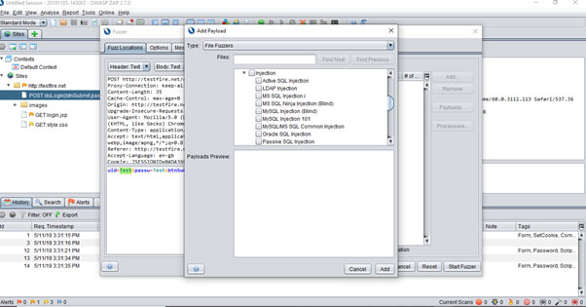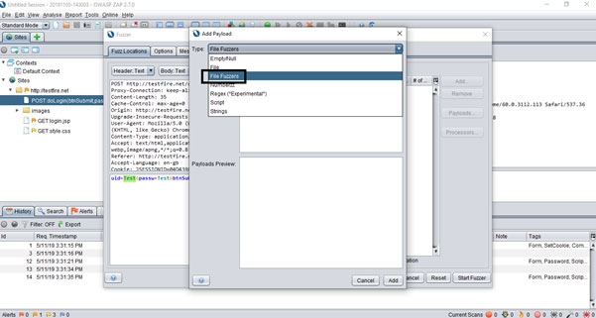

1. Scroll down the pane and select **SQL injection** as a payload for uid filed. Selected payloads must be seen in the Payloads Preview pane.

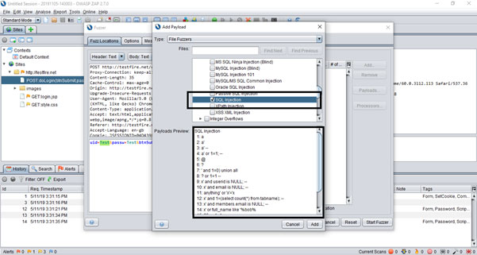

1. Click on the ‘Add’ button and observe that payload gets added for the uid field.

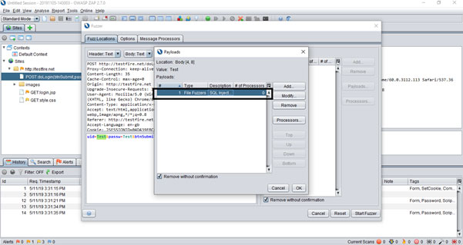

1. Click on Ok. Payload is now successfully added for the uid field.

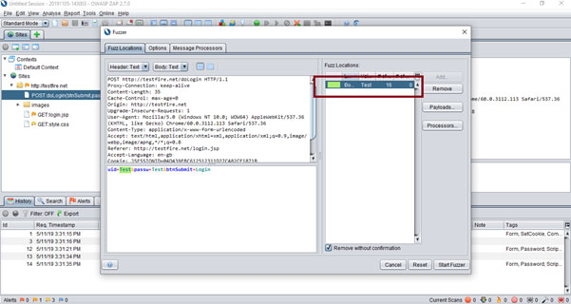

1. Similarly, add payload for the ‘passw’ field.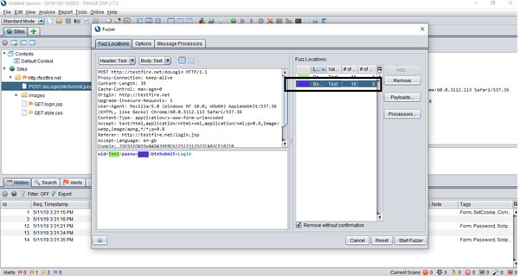
2. 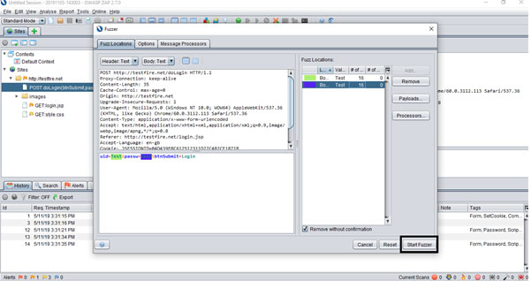Click on ‘Start Fuzzer’ and wait until it reaches 100%.

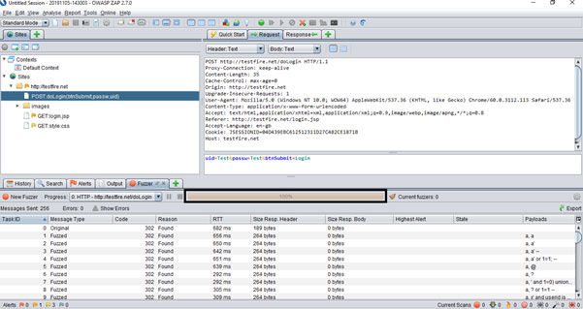

Finally, check the status code. If the code returns 302, i.e., redirected to next page, it means that the application is vulnerable to an SQL injection. We can utilize the same SQL queries in ‘uid’ and ‘passw’ fields and login into an application without knowing the actual password.

**PRACTICAL -10**

**Aim : Perform web application testing using DVWA .**

**1. Perform Manual SQL injection**

**2. XSS using DVWA**

**DVWA: Damn Vulnerable Web Application:**

* Damn Vulnerable Web App (DVWA) is a PHP/MySQL web application that is damn vulnerable.
* Its main goals are to be an aid for security professionals to test their skills and tools in a legal environment, help web developers better understand the processes of securing web applications and aid teachers/students to teach/learn web application security in a class room environment.
* The aim of DVWA is to practice some of the most common web vulnerabilities, with various levels of difficulty, with a simple straightforward interface.
* Note, there are both documented and undocumented vulnerabilities with this software. This is intentional. You are encouraged to try and discover as many issues as possible.

**DVWA Attacks:**

* Brute Force
* Command Injection
* File Upload
* Insecure CAPTCHA
* SQL Injection / SQL Injection (Blind)
* Weak Session IDs

**Demonstration**

* In order to exploit SQL injection vulnerabilities, we need to figure out how the query is built in order to inject our parameter in a situation that the query will remain true.
* For example, in the DVWA we can see a text field where it asks for user ID. If we enter the number 1 and we click on the submit button we will notice that it will return the first name and the surname of the user with ID=1.

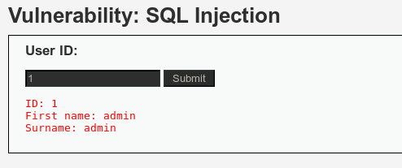

* The next step will be to try to identify what kind of database is running on the back-end in order to construct the queries accordingly and to extract the information that we want.
* This is very important because If we don’t know the database that exists behind we will not be able to exploit successfully the SQL injection vulnerability.
* Most of the times the web application technology (Java, ASP.NET, PHP etc.) will give us an idea of the database that the application is using. For example, ASP.NET applications often using Microsoft SQL Server, PHP applications is likely to use MySQL and Java probably Oracle or MySQL.
* Additionally, we can assume the database type from the web server and operating system of the target.
* For example, if the web server is running Apache and PHP and it is a Linux host then the database has more possibilities to be MySQL.
* If it is an IIS then it is probably Microsoft SQL Server.
* Of course, we cannot rely on these information, this is just for giving us an indication in order to speed the database fingerprint process.
* We can very easily identify the database type especially if we are in a non-blind situation.
* The basic idea is to make the database to respond in a way that it will produce an error message that it will contain the database type and version. For example, this can be achieved by a single quote because it will force the database to consider any characters that are following the quote as a string and not as SQL code and it will cause a syntax error.
* So now if we add a single quote on the vulnerable parameter id=’ this will make the database to generate an error message which as we can see from the image below it contains the database type which is MySQL server.

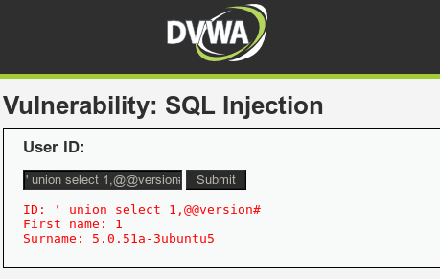

**PRACTICAL -11**

**Aim : Perform brute force attack using John the RIPPER.**

**Brute Force Attack**

* A brute force attack can manifest itself in many ways, but primarily consists in an attacker configuring predetermined values, making requests to a server using those values, and then analyzing the response.
* For the sake of efficiency, an attacker may use a dictionary attack (with or without mutations) or a traditional brute-force attack (with given classes of characters e.g.: alphanumeric, special, case (in)sensitive).
* Considering a given method, number of tries, efficiency of the system which conducts the attack, and estimated efficiency of the system which is attacked the attacker can calculate approximately how long it will take to submit all chosen predetermined values.
* For Example, the matching string that you are using for cracking passwords should include uppercase alphabets, special characters and numbers like ABC32@$
* The user gets a password on the successful match, but this effective process is slow. For example, a 10-character password including upper and lower letters along with numbers and special characters will take over 10 years to be guessed by a computer.
* The penetration testers, ethical hackers, security experts and other Cyber Security professionals use this tool to find weak algorithms and then make them strong so that they can't be hacked.
* Security professionals build their confidential files with a strong hash algorithm to prevent external unauthorized access.
* Hackers used it to crack multiple accounts and simply crack their credentials.
* Security experts use it to strengthen their encryption.
* It can also be used for hacking shells and passwords.
* SHA-crypt hashes.
* It provides a mangling feature which is a pre-processor in JTR that optimizes the word list to make the password cracking process faster.

**John the RIPPER**

* John the Ripper is the name of the password cracker tool that is developed by Openwall. As the name, it is used to crack password hashes by using its most popular inbuilt program, rules and codes that are also an individual password cracker itself in a single package.
* It automatically detects types of password hashes; you can also customize this tool according to your wish.
* It can be used to crack password-protected compressed files like Zip, Rar, Doc, pdf etc.
* The main objective of John the Ripper is to crack the password.
* There are many ways that can be supported but it is mainly known for Dictionary attacks. However, you can also run other types of attacks like Brute force attack, Rainbow Table etc.

**Practical/Demonstration**

1. Cracking a ZIP file:
   1. Now you can see that we have a zip file techofide.zip which is password protected and asking for a password to open it.

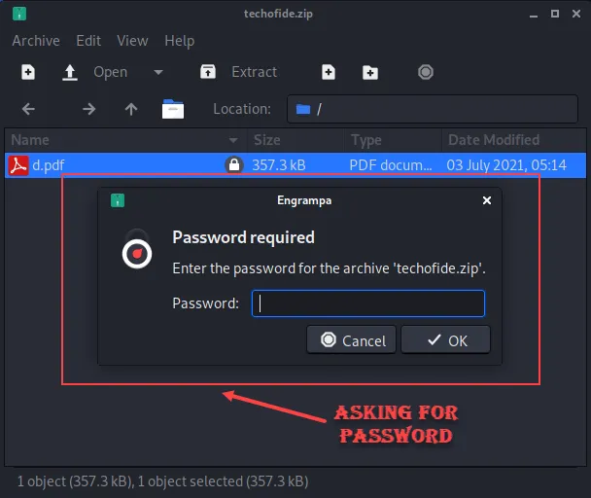

b) Now as we know JTR use hash to crack password, so we first need to generate a hash of our zip file. The below command will generate a hash of our techofide.zip file and store that generated hash value into a hash.txt file

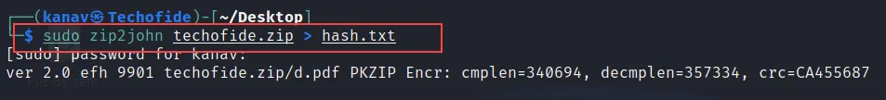***sudo zip2john techofide.zip > hash.txt***

c) Let us break it with our tool, so now we have a hash of our zip file that we will use to crack the password. In the below command we use the format option to specify the zip file and then the hash.txt file where we store our hash value.

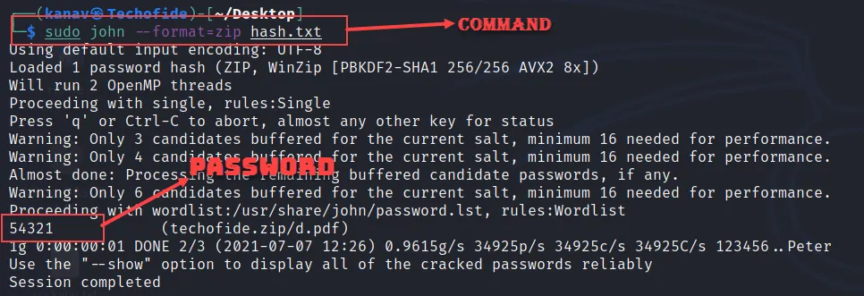***sudo john --format=zip hash.txt***

In the above picture, you can see our command complete the session and returns with the correct password 54321.

2. Cracking MD5 Password:

* + 1. In this example I am generating a hash by using md5 hash generator to show you how to crack MD5 formatted files password. In the below image you can see I have generated the hash of the 12345 strings. You can copy the MD5 hash to perform the same practical.
    2. In the below picture you can see the file sha1.txt. I have used the cat command to show you the data of the sha1.txt file, You can see the MD5 hash value 8772cc.

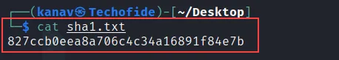

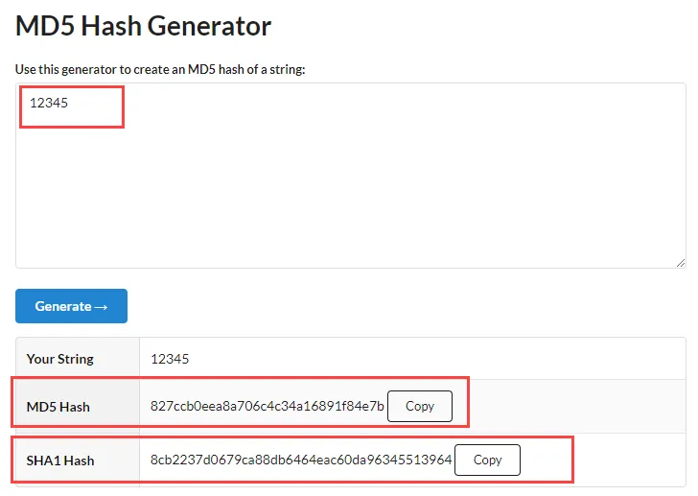

* + 1. Now let us crack the MD5 Hash, In the below command we have specified format along with the hash file.

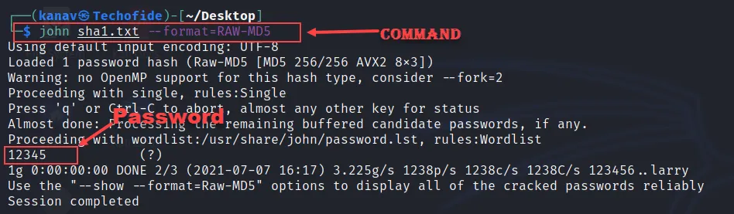***john sha1.txt --format=RAW-MD5***

In the above screenshot, you can see the output that cracks the hash and returns the 12345 passwords.

# **Conclusion: -**

Now we know what is John the Ripper, how to use John the Ripper, How John the Ripper password cracker works, how passwords can be cracked and also a tutorial on its real-life important uses, but this not get over yet there are lots of other things that can be done by JTR.7

However, remember that if the password is long, it will also take long time to crack.